A Project report on

**AUDIO AND VIDEO STREAMING USING Li-Fi**

Submitted in partial fulfillment of

Requirement for the award of degree of

BACHELOR OF TECHNOLOGY

IN

**Electronics and Communication Engineering**

Submitted By

**M. S. PAVAN ADITYA P. SIVA KRISHNA**

**(14981A0471) (14981A0470)**

**P. Hemanth Kumar B. SRAVAN KUMAR**

**(14981A0494) (15985A0407)**

Under the Guidance of

**Dr. CH. SRINIVASU**

***M. TECH, Ph. D***

Professor



**Department of Electronics and Communication Engineering,**

**RAGHU ENGINEERING COLLEGE**

**(Affiliated to Jawaharlal Nehru Technological University-Kakinada)**

**(2014 - 2018)**

**CERTIFICATE**

# RAGHU ENGINEERING COLLEGE

**Department of Electronics and Communication Engineering**



**CERTIFICATE**

This is to certify that the project report titled “Audio and Video streaming using Li- Fi” is being submitted by

B. Sravan Kumar bearing roll number 15985A0407 in B. Tech IV Year, II semester in the branch *Electronics and Communication Engineering* is a record bonafide work carried out by them. The results embodied in this report have not been submitted to any other University for the award of any degree.

**Head Of the Department**

**Dr. K. Phaninder Vinay**

***M. Tech, Ph. D***

**Professor,**

**Department of ECE,**

**Raghu Engineering College.**

**Internal Guide**

**Dr. CH. SRINIVASU**

***M. Tech, Ph. D***

**Professor,**

**Department of ECE,**

**Raghu Engineering College.**

**Raghu Engineering College.**

**EXTERNAL EXAMINER**

**ACKNOWLEDGEMENT**

**ACKNOWLEDGEMENT**

There are numerous to whom we owe our thanks for their help, support, advice and suggestions during the various stages of this project.

First and foremost, we express our sincere thanks to **Sri Kalidindi Raghu**, Chairman and Prof. **Sri P. Kameswara Rao**, Principal, Raghu Engineering College for their blessings in the successful completion of this project. They have been continuous source of inspiration with their cheerful countenance.

We would like to express our deep sense of gratitude to **Dr. K. Phaninder Vinay,** M. Tech, Ph. D, Prof.& Head, Department of Electronics and Communication engineering, for enlightening us with constructive suggestions by attending to our problems patiently and to improve the quality of work without whose /whole-hearted support, this project would not have been a reality.

We profusely thank our academic guide and mentor **Dr. CH. SRINIVASU,** M. Tech, Ph. D, professor for guiding us to achieve excellence besides providing a positive work environment. Under his able guidance at every step, we could complete this project within the stipulated period.

We would like to extend our gratitude to our Project Coordinator **Mr. Gupteshwar Sahu**, M. Tech,

(Ph. D) Associate Professor, Department of Electronics and Communication Engineering, for guiding our team and project work as our overall project guide, without this help we might haven’t achieved our work completely up to the extent of mark.

We would also like to extend our respect of thanks giving to **Mr. R. Govind,** M. Tech,Assistant Professor, Department of Electronics and Communication Engineering, for supporting us at every hurdle in our work with immense patience and extremely knowledgeable suggestions, without which we may not finish our work as desired.

Finally, we consider it our duty to take this opportunity to thank our entire teaching and non-teaching staff members and many friends who have extended their unstinted cooperation during this project work. We feel amply rewarded if the project is found useful.

**Submitted by:**

M. S. PAVAN ADITYA (14981A0471)

P. SIVA KRISHNA (14981A0470)

P. HEMANTH KUMAR (14981A0494)

B. SRAVAN KUMAR (15985A0407)

**CONTENTS**

1. Abstract…………………………………………………………………i
2. List of figures…………………………………………………………..ii
3. List of tables…………………………………………………………...iii
4. Symbols and Abbreviations…………………………………………....iv

**CHAPTER-1**

**INTRODUCTION__________________________________________1**

* 1. Objective…………………………………………………………………1
  2. Motivation and Problem Definition…………………...…………………2
  3. Hardware requirements…………………………………………………..2
  4. Software requirements…………………………………………………...3

**CHAPTER-2**

**HARDWARE DEVELOPMENT_____________________________4**

* 1. Hardware components……………………………………………………4
  2. LED Transmitter circuit………………………………………………….13
  3. Transmission of Signals using LED transmitters………………………...14
  4. Photo Diode Receiver circuit…………………………………………...14

**CHAPTER-3**

**SOFTWARE DEVELOPMENT______________________________15**

* 1. Introduction to MATLAB Software………………………………………15
  2. Software Block Diagram and Algorithm………………………………….23
  3. Design of Video to Frames Block………………………………………...24
  4. Design of RGB Frames to Grayscale Converter Block…………………...24
  5. Design of LED Transmitter Block……………………………………...…24
  6. Design of Photo Diode Receiver Block……………………………………25
  7. Design of Grayscale to RGB Frames Converter Block……………………25
  8. Design of Frames to Video Joiner Block…………………………………..26

**CHAPTER-4**

**IMPLEMENTATION AND RESULTS________________________27**

* 1. Hardware Design………………………………………………………..27
  2. Software functions………………………………………………………28
  3. Simulink Model…………………………………………………………31
  4. Hardware Output………………………………………………………..40
  5. Software Output………………………………………………………....40
  6. Results…………………………………………………………………...44

**CHAPTER-5**

**VALIDATION_____________________________________________48**

* 1. Applications……………………………………………………………...48
  2. Advantages……………………………………………………………….51
  3. Disadvantages…………………………………………………………….51

**CHAPTER - 6**

**CONCLUSION_____________________________________________56**

**CHAPTER-7**

**REFERENCES_____________________________________________58**

**ABSTRACT**

**ABSTRACT**

Li-Fi is a label for wireless-communication systems using light as a carrier instead of traditional radio frequencies, as in Wi-Fi. The voice, speech, video data information can be transmitted using Li-Fi technology with high data rates. This technology is named as Li-Fi transmission which stands for Light Fidelity. This invention can produce data rates faster than 10 Megabits per second which is much more than that of an average broadband speed of Wi-Fi connection and Bluetooth. Wireless communication has become a basic utility in personal and business life such that it becomes a fundamental of our lives, and this type of communication theory uses the radio spectrum for data transfer. There are limitations in using the radio spectrum i.e. capacity, efficiency, availability and security. The defects of Wi-Fi technology gave birth to the concept of Li-Fi (Light Fidelity) technology. Li-Fi can be defined as a light-based Wi-Fi. This technology mainly serves the purpose of transmitting data using retrofitting of LED bulbs that has high efficiency, durability and reliability. With the increasing popularity of solid state lighting devices, Visible Light Communication (VLC) properly known and Light Fidelity (Li-Fi) technology is globally recognized as an advanced and promising technology to realize short-range, high speed as well as large capacity wireless data transmission. In this project, prototype of real-time audio and video broadcast system using inexpensive commercially available light emitting diode (LED) lamps is being implemented, and with LED arrays is capable in supporting light illumination, data broadcast as well as video and audio streaming. Lighting model within room environment is designed and simulated, which indicates close relationship between layout of light sources and distribution of illuminance. Later, after the implementation of audio on the hardware setup is done, the video streaming is done using the MATLAB software for streaming it using the available LED block in Simulink. The final objective of Li-Fi development is the application of off-the-shelf LEDs in home environment wireless network to satisfy the needs of both illumination and data transmission.

**LIST OF FIGURES**

**Chapter - 2:**

1. LED and symbol of LED
2. LED Architecture
3. Resistors
4. Capacitor
5. Op-Amp IC - µA 741
6. Potentiometer
7. Battery
8. Transistor and pin diagram
9. 3.5mm Jack port

2.10 Solar Cell

2.11 Speaker

2.12 Transmitter circuit

2.13 Receiver Circuit

**Chapter - 3:**

1. Figure 3.1
2. Figure 3.2
3. Figure 3.3
4. Figure 3.4
5. Software Block Diagram

**Chapter - 4:**

1. Figure 4.1
2. Figure 4.2
3. Transmitter Simulink Model
4. Figure 4.4
5. Simulink LED
6. Receiver Simulink Model
7. Hardware Transmitter Image
8. Hardware Transmitter Image
9. Software Output-1

4.10 Software Output-2

4.11 Software Output-3

4.12 Software Output-4

4.13 Transmitter Result

4.14 Hardware Circuit Result

4.15 Final Hardware setup and Result

4.16 Software Transmitted Inputs

4.17 Software Received Outputs

4.18 Software Transmitted Video Output

**Chapter - 5:**

1. Optical underwater communication system
2. Vehicle visible light communications
3. Indoor Navigation system for Blind people

**Chapter - 6:**

1. Road Map

**LIST OF TABLES**

**Chapter - 2:**

1. Resistor Color Codes
2. 3.5mm Jack Configuration

**Chapter - 3:**

1. Basic arithmetic operators

**Chapter - 4:**

1. Characteristics of Repeating Sequence Stair block
2. Characteristics of Reshape block

**Chapter - 5:**

1. Comparison between Bluetooth, Li-Fi and Wi-Fi technologies
2. Differences between Li-Fi and Wi-Max technologies
3. Comparison of speed of various wireless technologies

**SYMBOLS AND ABBREVIATIONS**

Li- Fi : Light Fidelity

LED : Light Emitting Diode

BJT : Bi-Polar Junction Transistor

VLC : Visible Light Communication

IC : Integrated Circuit

Op-Amp : Operational Amplifier

PCB : Printed Circuit Board

RGB : Red Green Blue

PNG : Portable Network Graphics

JPG : Joint Photographic experts Group

AVI : Audio Video Interleaved

RF : Radio Frequency

OOK : On-Off Keying

Gbps : Gigabit per Second

Mbps : Megabit per Second

IrDA : Infrared Data Association

*NFC* : Near Field Communication

**CHAPTER-1**

**INTRODUCTION**

Visible light communications (VLC) is the name given to an optical wireless communication system that carries information by modulating light in the visible spectrum (400–700 nm) that is principally used for illumination. The communications signal is encoded on top of the illumination light. Interest in VLC has grown rapidly with the growth of high power light emitting diodes (LEDs) in the visible spectrum.

VLC was invented in late 1990’s in the countries like Germany, Korea and Russia. Later in 2011, Harald Hass continued the work on this technology and started integrating the concept into an LED table lamp. On 12th July 2011, at TED talks he demonstrated the concept of Li-Fi on stage by transmitting a video through a table lamp LED transceiver.

* 1. **Objective**

The objective of the project is to achieve audio and video streaming using Li-Fi technology that is using visible light spectrum as the medium of transmission. Digitalising the Analog input and giving it to the LED lamp through the lamp driver circuit and reproducing it back at the receiver by using a photo diode sensor is the process implemented for it. The main purpose of Li-Fi technology is to overcome the defects of Wi-Fi communication and to avoid the hazardous effects caused by the other spectrums if implemented. Implementation of Li-Fi results in achieving high speed data transfer at very low cost along with an assurance of safety to the environment. The motivation to use the illumination light for communication is to save energy by exploiting the illumination to carry information and, at the same time, to use technology that is “green” in comparison to radio frequency (RF) technology, while using the existing infrastructure of the lighting system. The necessity to develop an additional wireless communication technology is the result of the almost exponential growth in the demand for high-speed wireless connectivity. Emerging applications that use VLC include: a) indoor communication where it augments Wi-Fi and cellular wireless communications which follow the smart city concept, b) communication wireless links for the internet of things (IOT), c) communication systems as part of intelligent transport systems (ITS), d) wireless communication systems in hospitals, e) toys and theme park entertainment, and f) provision of dynamic advertising information through a smart phone camera.

* 1. **Justification**

Wi-Fi uses radio waves spectrum for transmitting the data. Since this band is congested and it is of a small finite range its capacity leads to dry up. Even though the demand for wireless network is increasing day by day the number of base stations available are limited. The cost of installation of a base station and maintaining it at optimum temperatures is more expensive. This technology even has lesser bandwidths with a lower factor of efficiency. Its availability is limited and is less secure. These all issues in radio spectrum laid path for opting a method using another spectrum. Even though Gama rays have higher frequency the visible rays, Gama rays can’t be used as they could be dangerous. X-rays also have similar health issues. They can also be harmful when our body is continuously exposed to them. Ultraviolet light is good for place without people, but otherwise they are extremely dangerous for the human body. Infrared spectrum is avoided due to the cause of eye safety regulation, so they can only be used with low power. These problems with every spectrum leads to the exception for their use. So, the only spectrum which could provide a good transmission medium under safety conditions is the visible light spectrum.

* 1. **Hardware requirements**

The main aspects of Hardware simulation are as follows,

1. Comparator Circuit

A Comparator circuit is designed for generating a pulsed waveform according to the values of the input signals. It compares the input waves with the reference voltage and generates the pulses.

1. LED Driver Circuit

The LED driver receives the pulsed output from the comparator as input. It drives the LED circuit On and Off according to the pulsed input.

1. Transmitter Circuit

The circuit of LEDs is driven according to the LED driver circuit and the transmission is done according to the LED river output.

1. Receiver Circuit

The Receiver circuit receives the input from the transmitter and processes it as output audio signals.

1. Amplifier Circuit

The amplifier circuit amplifies the audio signal and is connected to the speaker.

* 1. **Software requirements**

The different stages of Software simulation are as follows,

1. Frames Divider Block

This block is used to divide the input video into frames of its seconds.

1. Image Transmitter Block

The transmitter block receives the images and converts it into grayscale and transmits them as a stair case signals.

1. Receiver Block

The receiver block receives the staircase waveform and obtains the pixel values from the waveform. Later it converts them into images of grayscale and to their RGB forms.

1. Video Joiner Block

The obtained RGB images and made to frames and joined back into a video and is sent as output.

**CHAPTER-2**

**HARDWARE DEVELOPMENT**

1. **Hardware components**

The different types of hardware components used for the design of the hardware circuit are mentioned as below,

1. **LED**

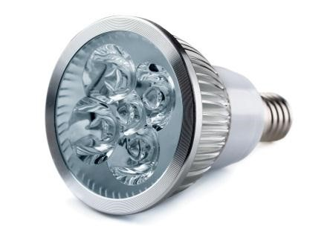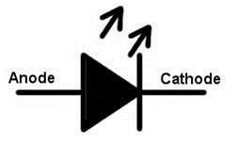

**Fig. 2.1** **LED and symbol of LED**

The most important requirement that a light source must meet in order to serve communication purposes is the ability to be switched on and off repeatedly in very short intervals. By utilizing the advantage of fast switching characteristics of LED‟s compared with the conventional lightning, the LED illumination is used as a communication source. Since the illumination exists everywhere, it is expected that the LED illumination device will act as a lighting device and a communication transmitter simultaneously everywhere in a near future.

Typically, red, green, and blue LEDs emit a band of spectrum, depending on the material system. The white LED draws much attention for the illumination devices. Comparing the LED illumination with the conventional illumination such as fluorescent lamps and incandescent bulbs, the LED illumination has many advantages such as high efficiency, environment-friendly manufacturing, design flexibility, long lifetime, and better spectrum performance.

LEDs emit light when energy levels change in the semiconductor diode. This shift in energy generates photons, some of which are emitted as light. The specific wavelength of the light depends on the difference in energy levels as well as the type of semiconductor material used to form the LED chip. Solid-state design allows LEDs to withstand shock, vibration, frequent switching (electrical on and off shock) and environmental (mechanical shocks) extremes without compromising their famous long life typically 100,000 hours or more.

The basic LED consists of a semiconductor diode chip mounted in the reflector cup of a lead frame that is connected to electrical (wire bond) wires, and then encased in a solid epoxy lens. The architecture of LED is shown in Fig.

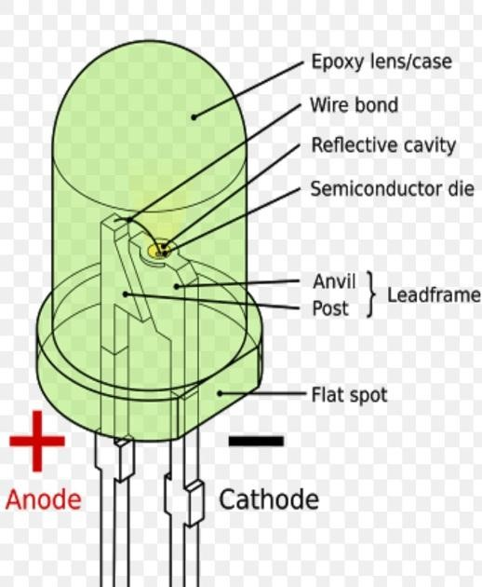

**Fig. 2.2** **LED Architecture**

1. **Resistors**

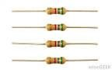

**Fig. 2.3** **Resistors**

Resistors are the most commonly used component in electronics and their purpose is to create specified values of current and voltage in a circuit. The unit for measuring resistance is the OHM. (The Greek letter Ω - called Omega). Higher resistance values are represented by

"k" (kilo-ohms) and M (Mega ohms). For example, 120 000 Ω is represented as 120k, while 1200000 Ω is represented as 1MΩ. The dot is generally omitted as it can easily be lost in the printing process. In some circuit diagrams, a value such as 8 or 120 represents a resistance in ohms. Another common practice is to use the letter E for resistance in ohms. The letter R can also be Resistor Markings.

Resistance value is marked on the resistor body. Most resistors have 4 bands. The first two bands provide the numbers for the resistance and the third band provides the number of zeros. The fourth band indicates the tolerance. Tolerance values of 5%, 2%, and 1% are used. The following t*able shows the Color Code used to identify resistor values.

**Table 2.1 Resistor Color Codes**

|  |  |  |  |  |
| --- | --- | --- | --- | --- |
| COLOR | DIGIT | MULTIPLIER | TOLERANCE | TC |
| Silver |  | x 0.01 W | ±10% |  |
| Gold |  | x 0.1 W | ±5% |  |
| Black | 0 | x 1 W |  |  |
| Brown | 1 | x 10 W | ±1% | ±100*10-6/K |
| Red | 2 | x 100 W | ±2% | ±50*10-6/K |
| Orange | 3 | x 1 kW |  | ±15*10-6/K |
| Yellow | 4 | x 10 kW |  | ±25*10-6/K |
| Green | 5 | x 100 kW | ±0.5% |  |
| Blue | 6 | x 1 MW | ±0.25% | ±10*10-6/K |
| Violet | 7 | x 10 MW | ±0.1% | ±5*10-6/K |
| Grey | 8 | x 100 MW |  |  |
| White | 9 | x 1 GW |  | ±1*10-6/K |

1. **Capacitors**

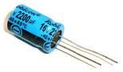

**Fig. 2.4** **Capacitor**

A capacitor is a two-terminal, electrical component. Along withresistorsand inductors, they are one of the most fundamentalpassivecomponents we use. What makes capacitors special is their ability tostore energy, they’re like a fully charged electric battery*.* Caps, as we usually refer to them, have all sorts of critical applications in circuits. Common applications include local energy storage. Capacitance is its Unit**.** Not all capacitors are created equal. Each capacitor is built to have a specific amount of capacitance. The capacitance of a capacitor tells youhow much charge it can store**,** more capacitance means more capacity to store charge. The standard unit of capacitance is called the farad**,** which is abbreviated F. It turns out that a farad is a lot of capacitance, even 0.001F (1 milli farad – 1mF) is a big capacitor. Usually we’ll see capacitors rated in the Pico- (10-12) to microfarad (10-6) range.

1. **IC 741**

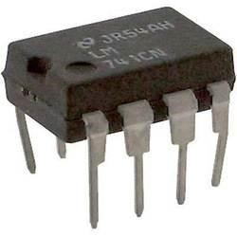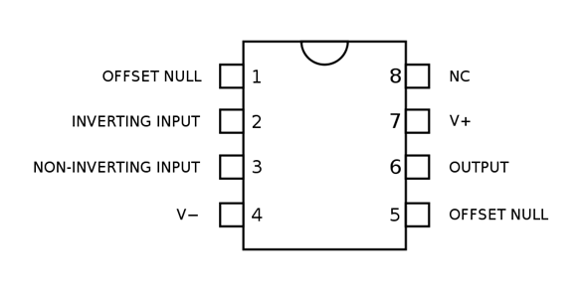

**Fig. 2.5** **Op-Amp IC - µA 741**

An operational amplifier (op-amp) is a DC-coupled high-gain electronic voltage amplifier with a differential input and, usually, a single-ended output. In this configuration, an op-amp produces an output potential (relative to circuit ground) that is typically hundreds of thousands of times larger than the potential difference between its input terminals.

Operational amplifiers had their origins in analog computers, where they were used to do mathematical operations in many linear, non-linear and frequency-dependent circuits. The popularity of the op-amp as a building block in analog circuits is due to its versatility. Due to negative feedback, the characteristics of an op-amp circuit, its gain, input and output impedance, bandwidth etc. are determined by external components and have little dependence on temperature coefficients or manufacturing variations in the op-amp itself.

Op-amps are among the most widely used electronic devices today, being used in a vast array of consumer, industrial, and scientific devices. Many standard IC op-amps cost only a few cents in moderate production volume; however, some integrated or hybrid operational amplifiers with special performance specifications may cost over $100 US in small quantities. Op-amps may be packaged as components or used as elements of more complex integrated circuits. The op-amp is one type of differential amplifier. Other types of differential amplifier include the fully differential amplifier (similar to the op-amp, but with two outputs), the instrumentation amplifier (usually built from three op-amps), the isolation amplifier (similar to the instrumentation amplifier, but with tolerance to common-mode voltages that would destroy an ordinary op-amp), and negative feedback amplifier (usually built from one or more op-amps and a resistive feedback network).

**Features of Op-Amp IC**

Short-Circuit Protection

Offset-Voltage Null Capability.

Large Common-Mode and Differential Voltage Ranges. No Frequency Compensation Required and Latch up741 is general Purpose operational amplifier.

The device exhibits high stability.

It can be configured in inverting and Non-Inverting Mode

It can be used to implement comparators, Astable and Monostable Multi-vibrators, Amplifiers, etc...

1. **Potentiometer**

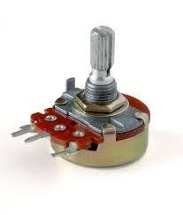

**Fig. 2.6** **Potentiometer**

A potentiometer, informally a pot, is a three-terminal resistor with a sliding or rotating contact that forms an adjustable voltage divider. If only two terminals are used, one end and the wiper, it acts as a variable resistor or rheostat.

The measuring instrument called a potentiometer is essentially a voltage divider used for measuring electric potential (voltage); the component is an implementation of the same principle, hence its name.

Potentiometers are commonly used to control electrical devices such as volume controls on audio equipment. Potentiometers operated by a mechanism can be used as position transducers, for example, in a joystick. Potentiometers are rarely used to directly control significant power (more than a watt), since the power dissipated in the potentiometer would be comparable to the power in the controlled load.

1. **Battery (9 V)**

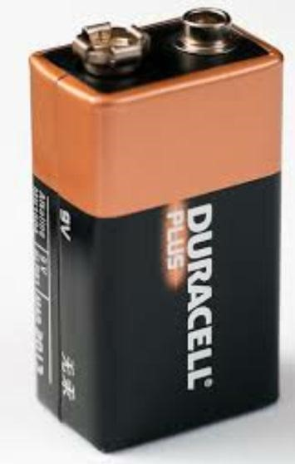

**Fig. 2.7** **Battery**

9 V Battery is used as the source for the circuit it supplies the required voltage for the circuit

1. **Transistor BC-548**

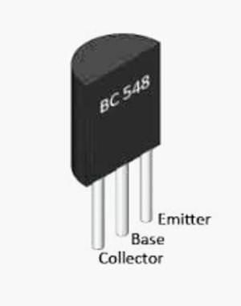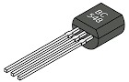

**Fig. 2.8** **Transistor and pin diagram**

It is general purpose silicon, NPN, bipolar junction transistor. It is used for amplification and switching purposes. The current gain may vary between 110 and 800. The maximum DC current gain is 800.Its equivalent transistors are 2N3904 and 2SC1815. These equivalent transistors however have different lead assignments. The variants of BC548 are 548A, 548B and 548C which vary in range of current gain and other characteristics. The transistor terminals require a fixed DC voltage to operate in the desired region of its characteristic curves. This is known as the biasing. For amplification applications, the transistor is biased such that it is partly on for all input conditions. The input signal at base is amplified and taken at the emitter. BC 548is used in common emitter configuration for amplifiers. The voltage divider is the commonly used biasing mode. For switching applications, transistor is biased so that it remains fully on if there is a signal at its base. In the absence of base signal, it gets completely off.

1. **3.5mm Jack male port**

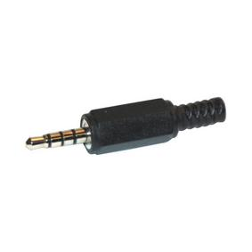

**Fig. 2.9** **3.5mm Jack port**

A phone connector, also known as phone jack, audio jack, headphone jack or jack plug, is a family of electrical connectors typically used for [analog audio signals](https://en.wikipedia.org/wiki/Analog_signal).

The phone connector is cylindrical in shape, with a grooved tip to retain it. In its original audio configuration, it typically has two, three, four and, occasionally, five contacts. Three-contact versions are known as *TRS connectors*, where *T* stands for ["tip"](https://en.wikipedia.org/wiki/Tip_and_ring), *R* stands for ["ring"](https://en.wikipedia.org/wiki/Tip_and_ring) and *S* stands for "sleeve". Ring contacts are typically the same diameter as the sleeve, the long shank. Similarly, two-, four- and five- contact versions are called *TS*, *TRRS* and *TRRRS connectors* respectively. The outside diameter of the "sleeve" conductor is 1⁄4 inch (6.35 millimetres). The "mini" connector has a diameter of 3.5 mm (0.14 in) and the "sub-mini" connector has a diameter of 2.5 mm (0.098 in).

**Table 2.2 3.5mm Jack Configuration**

|  |  |  |  |  |
| --- | --- | --- | --- | --- |
|  | **Unbalanced mono in/out** | **Unbalanced mono insert** | **Balanced mono in/out** | **Unbalanced stereo** |
| Tip | Signal | Send or return signal | Positive/*hot* | Left channel |
| Ring | Ground or *no Connection* | Return or send signal | Negative/*cold* | Right channel |
| Sleeve | Ground | | | |

1. **Solar Panel**

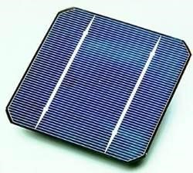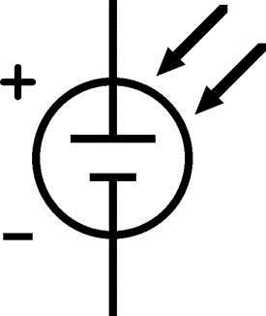

**Fig. 2.10** **Solar Cell**

A Solar cell is an electrical device that converts the energy of Light Directly to electric signal or analog signal by the photovoltaic effect, which is a chemical physical phenomenon. When photons are strikes on its walls electron flow occurs which will store as electrical energy. It have slower Time response as their area increases. Solar cells are formed connecting large Number of Photo Detectors connected in series. It works in the Reverse Biased Mode. Usually the Efficiency of solar cell is Low. Even though it regarded as Green Technology.

1. **Speaker**

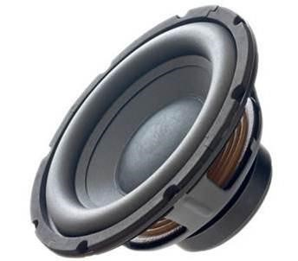

**Fig. 2.11** **Speaker**

In this project we use Speaker which has in-built Amplifier, which Amplifies the Analog signal received from the output of the Solar cell. It also helps to remove any phase errors that may occurred during the Transmitting or Processing of the input signal. The main Function of a speaker is to convert Electrical or Analog Signals in to the Audible form to reach the Receptor. It converts the sound signal with the help of Electromagnets Present in the Speaker. Hence the Receptor Receive the input that has been transmitted from the Transmitter.

1. **LED Transmitter Circuit**



**Fig 2.12** **Transmitter circuit**

The above figure depicts the transmitter circuit of the *Li-Fi* circuit. We know that carrier waves can take signals along destinations, so this is simple concept when we put photons with speed of light by source to destination it can also carry signals of low frequency to destination. So, we build a circuit which can modulate light with low frequency signals. Take input from an audio device, the input will be very low audio signals of 20Hz to 20KHz. These signals paces through C1 (100nf) where DC (Direct Current) components are filtered and removed. Through R3 100kΩ which is a current limit for comparator µA741 (Op-Amp) to protect it from the high current which cause destruction of the Op-Amp. Through R1 100kΩ and R4 100kΩ, voltage at the inverting terminal of the Op-Amp limit to 5v/2 = 2.5v. Input signal at pin 3 of op-amp and compare with pin 2 of Op-Amp and output will be present at the Pin No 6 of the Op-Amp IC. 470kΩ pot or feedback gain controller to control volume at output of the Op-Amp If there is no input is fed to the Comparator, a Positive DC wave will present at pin 6 of Op-Amp, which make transistor Q1 keep alive and LED starts to glow Continuously. The Capacitors C3, C4 (Both are 470µF) are filters to reduce AC components spike in circuit. Whenever signals interrupt through pin 3 of op-amp (input from Audio device). The Comparator compares the input signal with the Reference Voltage and produce an Pulse wave output at the Pin 6. The width of the pulse wave is controlled by the Input signal Frequency. The Pulse signal is equivalent to the ON/OFF Signal which control the intensity of the Light Source aka LED (D1). The Pulse wave is further Amplified and Modulated using Transistor BC548 (T1), which is an Amplifier Modulator having high current gain. The transistor will act as a Lamp Driver and drives the LED. LED emits light according to the pulse wave form and make VLC (Visible light communication) alive. Since the blinking of the LED is controlled by the input signal, it will take place in Nano Seconds (ns) it cannot detect by Human eyes.

1. **Transmission of Data through LEDs**

The comparator circuit sends the data as a square wave output to the LED driver circuit. The LED driver circuit drives the array of LEDs according to the obtained pulses and shows an ON blink and OFF blink on the LEDs according to the 0s and 1s of the pulsed wave. This drives out the input audio from the LEDs in the form of data with visible light as the medium. This data is received and decoded using the photo diode present at the receiver part.

1. **Photo Diode Receiver Circuit**



**Fig 2.13** **Receiver Circuit**

The Solar cell is used to detect the Light from the Transmitting LEDs and it produces an Analog output corresponding to the input signal. The frequency of the analog will be same as that of input signal since the flickering of LED is controlled by the input signal and solar cell detects only the fluctuation in the LED signal and produces the output. The output is then amplified using IC 741 amplifier circuit. It also helps in removing any phase changes occurs in the transmitted signal. The Amplified signal is fed to the speaker. The speaker converts the analog signal to the Audible Sound signalusing the electromagnet present in the Speaker.

**CHAPTER-3**

**SOFTWARE DEVELOPMENT**

1. **Introduction to MATLAB Software**
   1. What Is MATLAB?

MATLAB® is a high-performance language for technical computing. It integrates computation, visualization, and programming in an easy-to-use environment where problems and solutions are expressed in familiar mathematical notation. Typical uses include

Math and computation

Algorithm development

Modeling, simulation, and prototyping

Data analysis, exploration, and visualization

Scientific and engineering graphics

Application development, including graphical user interface building

MATLAB is an interactive system whose basic data element is an array that does not require dimensioning. This allows you to solve many technical computing problems, especially those with matrix and vector formulations, in a fraction of the time it would take to write a program in a scalar non-interactive language such as C or FORTRAN.

The name MATLAB stands for matrix laboratory. MATLAB was originally written to provide easy access to matrix software developed by the LINPACK and EISPACK projects. Today, MATLAB uses software developed by the LAPACK and ARPACK projects, which together represent the state-of-the-art in software for matrix computation.

MATLAB has evolved over a period of years with input from many users. In university environments, it is the standard instructional tool for introductory and advanced courses in mathematics, engineering, and science. In industry, MATLAB is the tool of choice for high-productivity research, development, and analysis.

MATLAB features a family of application-specific solutions called toolboxes. Very important to most users of MATLAB, toolboxes allow you to learn and apply specialized technology. Toolboxes are comprehensive collections of MATLAB functions (M-files) that extend the MATLAB environment to solve classes of problems. Areas in which toolboxes are available include signal processing, control systems, neural networks, fuzzy logic, wavelets, simulation, and many others.

* 1. STARTING OF MATLAB

After logging into your account, you can enter MATLAB by double-clicking on the MATLAB shortcut icon (MATLAB 8.1.0) on your Windows desktop. When you start MATLAB, a special window called the MATLAB desktop appears. The desktop is a window that contains other windows. The major tools within or accessible from the desktop are:

* The COMMAND WINDOW
* The COMMAND HISTORY
* The WORKSPACE
* The CURRENT DIRECTORY
* The HELP BROWSER
* The START BUTTON

Here in Figure 3.1, we are into the Matlab software where we can examine the Command window, Command history and the workspace along with different options available in Matlab. To start an editor window or the m file we are provided with an option as New Script where we can write a program and to run it.

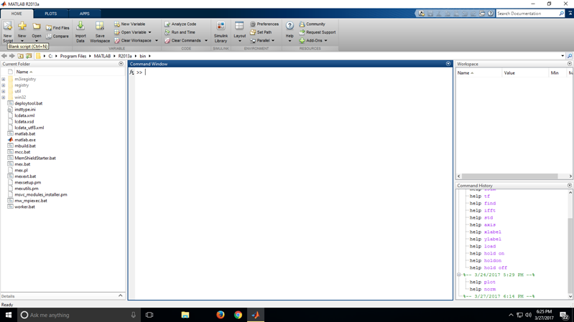

**Fig 3.1**

Well, in Figure 3.2 we can see the editor window where program was written, we also have various options to execute our program. When you run a program the file automatically saves itself and if at all there are any errors in our program those will be displayed in a command window.

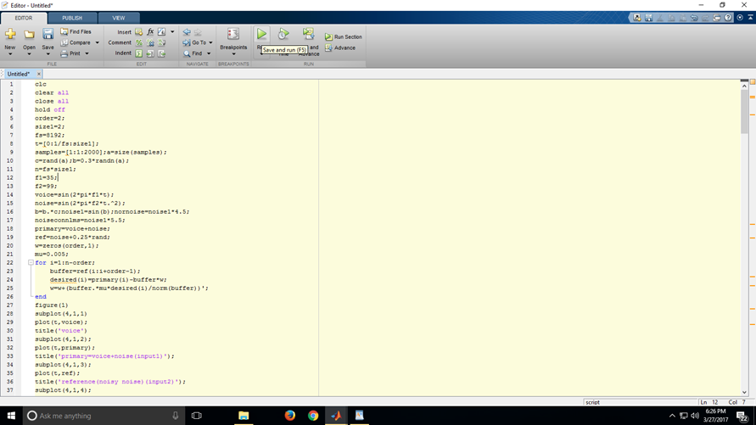

**Fig 3.2**

Saving m file is shown in Figure 3.3:

In the same folder location where the files related with program exists.

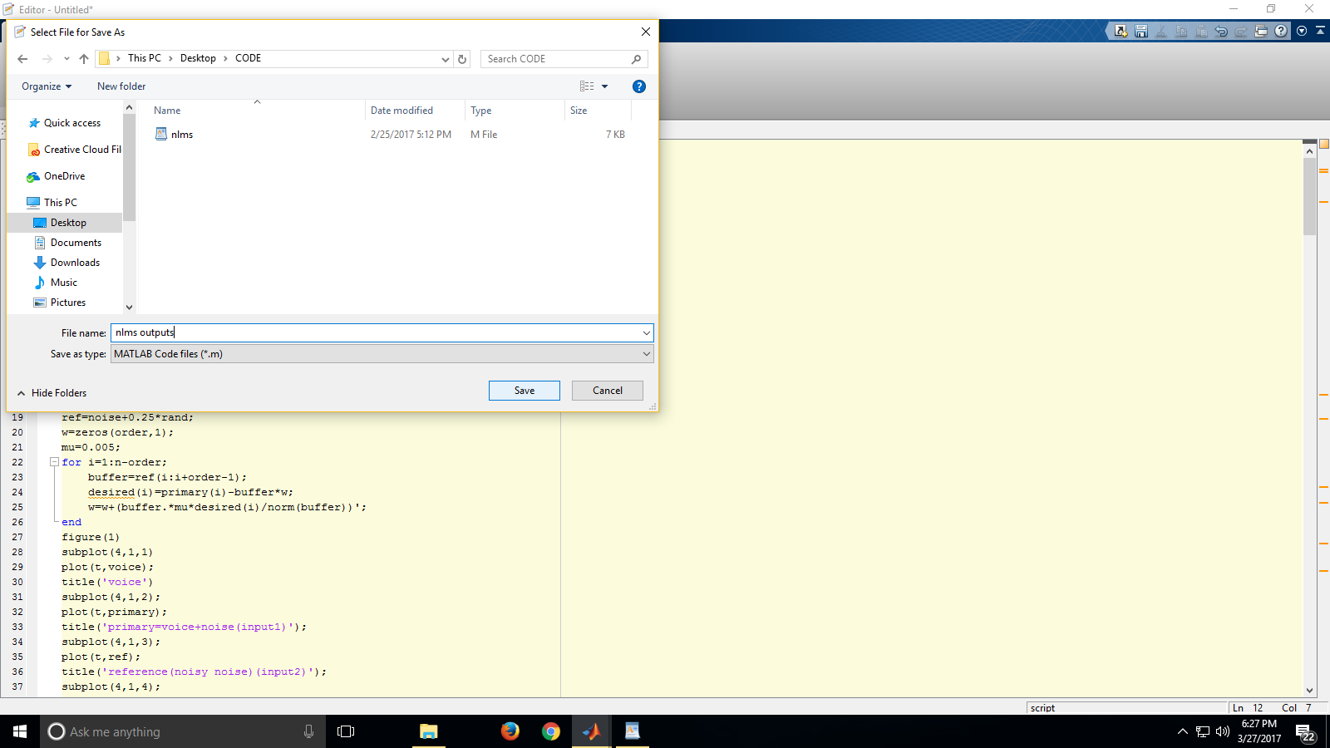

**Fig. 3.3**

Errors if any:

we are provided with line number so reslove the error and to get back with results.

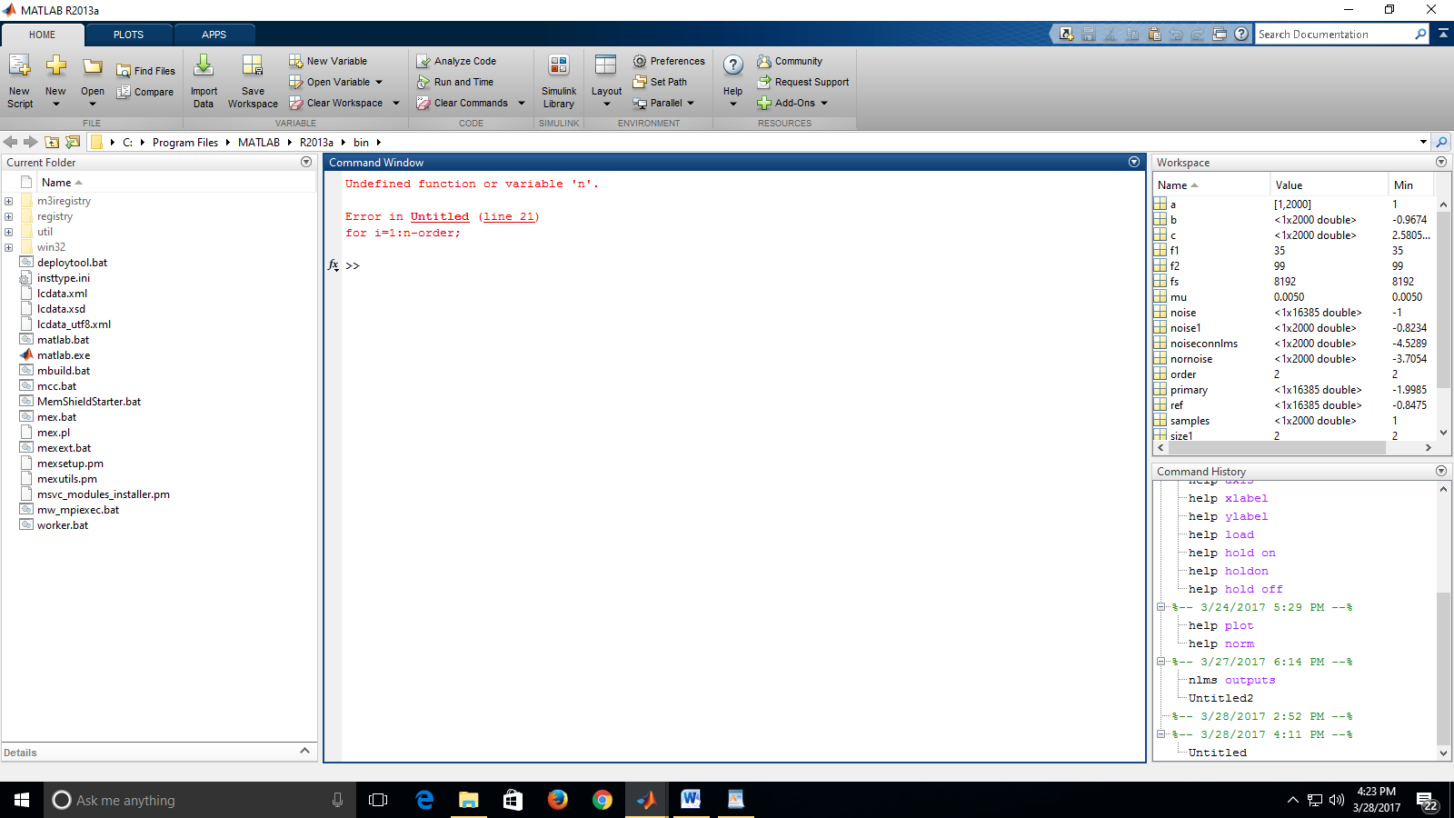

**Fig. 3.4**

When MATLAB is started for first time, the screen looks like the one that shown in the figure 1.1. This illustration also shows the default configuration of the MATLAB desktop. You can customize the arrangement of tools and documents to suit your needs.

Now, we are interested in doing some simple calculation. We will assume that you have sufficient understanding of your computer under which MATLAB is being run.

You are now faced with the MATLAB desktop on your computer which contains

The prompt (>>) in the Command Window. Usually, there are 2 types of prompt:

>>for full version

EDU> for educational version

Note: To simply the notation, we will use this prompt, >>, as a standard prompt sign, through our MATLAB version is for educational purpose.

Table 3.1 gives the partial list of arithmetic operators.

**Table 3.1 Basic arithmetic operators**

|  |  |  |
| --- | --- | --- |
| **SYMBOLS** | **OPERATIONS** | **EXAMPLES** |
| **+** | Addition | 2+3 |
| **-** | Subtraction | 2-3 |
| * | Multiplication | 2*3 |
| / | Division | 2/3 |
| % | Modulo division | 2%3 |

* 1. Quitting MATLAB

To end your MATLAB session, type quit in the command window, or select

File->Exit MATLAB in the desktop main menu.

* 1. Creating MATLAB variables

MATLAB variable is created with an assignment statement. The syntax variable assignment is

Variable name = a value (or an expression)

For example,

>>x =expression

Where an expression is a combination of numerical values, mathematical operation variables, and function calls. On other words, expression can involve:

* Manual entry
* Built in function
* User defined functions
  1. Getting help

To view the online documentation, select MATLAB help from help menu or MATLAB help directly in the command window. The preferred method is to use the help browser. The help browser can be started by selecting the “?” Icon from the desktop toolbar on the other hand, information about my command is available by typing

>>help command

Another way to get help is to use the look for command. The look for command differs from the help command. The help command searches for an exact function name match, while the look for command searches the quick summary information in each function for a match. for example, suppose that we were looking for a function to take the inverse of a matrix. since MATLAB does not have a function named inverse, the command help inverse will produce nothing. On the other hand, the command ‘look for inverse’ will produce detailed information, which includes the function of interest, inv.

>>look for inverse

Note: At this particular time of our study, it is important to emphasize one main point. Because MATLAB is a huge program; it is impossible to cover all the details of each function one by one. However, we will give you information how to get help.

Here are some examples:

Use on line help to request info on a specific function

>>help sqrt

In the current version (MATLAB version 7), the doc function opens the on-line version of help manual this is very helpful for more complex commands.

>>doc plot

Use look for to find function by keywords the general form is

>>look for function name.

* 1. **Overview**

MATLAB has an excellent set of graphic tools. Plotting a given data set or the results of computation are possible with very few commands. You are highly encouraged to plot mathematical functions and results of analysis as often as possible. Trying to understand the mathematical equations with graphics is an enjoyable and very efficient way of learning mathematics. Being able to plot mathematical functions and data freely is the most important step, and this section is written to assist you to do just that.

* 1. **Creating simple plot**

The basic MATLAB graphing procedure , for example in 2D , is to take a vector of x-coordinates , x =(x1;:::; xN), and a vector of y-coordinates , y=(y1;:::;yN), locate the points (xi;yi), with i=1;2;:::; n and then join them by straight lines. You need to prepare x and y in an identical array form; namely, x and y are both row arrays and column arrays of the same length.

Note: the plot function has different forms depending on the input arguments. If y is a vector plot (y) produces a piecewise liner graph of the elements of y versus the index of the elements of y. if we specify two vectors, as mentioned above, plot(x,y) produces a graph

* 1. **Implementation**

We implement various algorithms for cancellation of noise and thereby on analyzing the obtained output waveforms we would be able to suggest the best suitable adaptive filtering algorithm for cancelling of noise in a communication system.

In the present context we are concerned with adaptive filters. Here we considered Regularization NLMS in which we are concern about Optimal regularization NLMS and Sub Optimal Regularization NLMS algorithms with fixed $β$ value and by varying the $β$ value for determining the NSR value of the system and the error rate.

1. **Software Block Diagram and Algorithm**

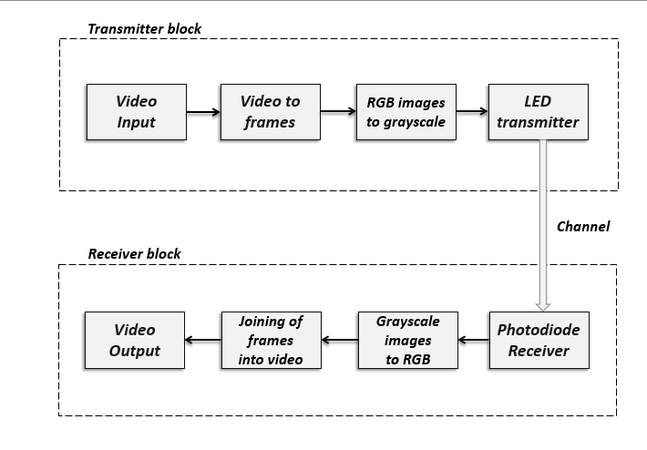

**Fig. 3.5 Software Block Diagram**

**Algorithm:**

Step - 1: Read the Video file as an input to the video Input block

Step - 2: Determine the number of frames in the video and divide them into

their respective RGB images

Step - 3: Convert these RGB images into their respective grayscale form by

removing the colour components in them

Step - 4: Input these grayscale images to the LED block in Simulink and

modulate the LED according their pixel values

Step - 5: Receive the transmitted images through the photodiode block.

Step - 6: Convert the grayscale images back into their original RGB form.

Step - 7: Join all the RGB frames back to form the original video

Step - 8: Output the joined video and save it using MATLAB.

1. **Design of Video to Frames Block**

The Video to frames block operates to divide the given input into its respective number of frames.

The input for this block is the video which is to be transmitted. The input video is read to the workspace and then operated under a loop for cutting the frames.

The for loop cuts the number of frames per second and writes them as files to the file manager in the system and loads them to the specified folder in the system memory

This block operates on the Matlab functions VideoReader, imwrite and imread.

1. **Design of RGB Frames to Grayscale Converter Block**

This block operates to change the dimensions of an existing image into the required dimensions suitable for our transmission.

The RGB frames written from the video to frames block are accessed one by one and operated in the RGB to grayscale convertor block.

The frames saved from the previous block are of RGB format and are 3 dimensional, the transmission of the images in the project can only be done under 1 dimension. Hence, the RGB images are converted into their respective grayscale formats.

This block divides an RGB image into its respective Red, Green and Blue grayscale images and saves them back at the required location.

This block can also operate for resizing and reshaping of the image size.

This block operates on the Matlab functions imread, save, imwrite, rgb2gray.

1. **Design of LED Transmitter Block**

The LED transmitter block is designed in the SIMULINK part of Matlab.

The grayscale images saved from the previous block are again loaded to the workspace in the Matlab.

These images are shaped into a row vector of 1xN shape.

The pixel values of the vector are copied to the command window and are given to a ‘Repeating sequence stair’ block in Simulink. This block generates a staircase waveform according each value in the row vector.

This staircase signal is given as an input to the customized LED block which accepts the input and gives the same as output.

The three dimensions i.e. the red, green and blue grayscale images are accessed into three different staircase generator blocks and three different staircase signals are constructed for every image and are passed parallelly through three different custom LED blocks as the LED block accepts only one input at a time.

The outputs of the LED blocks are received by the 3 different ‘simout’ block which save their respective stair values in the form arrays of single column into the Matlab workspace with three different variable names.

This block is designed in Matlab Simulink using Repeating staircase generator, Simulink LED and To Workspace blocks.

1. **Design of Photo Diode Receiver Block**

The Photo Diode receiver block is also designed in the SIMLUNK part of Matlab.

Using three ‘From Workspace’ blocks the column vectors saved in the Matlab workspace are accessed again into the Simulink. These blocks are used as receivers for the data or signals transmitted through the LED blocks.

These three blocks are connected to three ‘image reshape’ blocks which are used to reshape the column vectors back to their original MxN sizes.

These three reshape blocks are concatenated using a ‘matrix concatenate’ block which places the three matrices one beside the other.

This block output is given to the ‘Matrix Viewer’ block for displaying the three images.

This block is designed in Matlab Simulink using From Workspace, Reshape, Matrix concatenate and Matrix Viewer blocks.

1. **Design of Grayscale to RGB Frames Converter Block**

This block operates in the inverse process for the previously defined RGB to grayscale block. It operates to convert or concatenate the three 1 dimensional grayscale images into one 2 dimensional RGB image.

This block receives the respective column vectors of the three grayscale images and reshapes them into their original MxN dimensions.

Later it combines the three grayscale images to form a single RGB image and the RGB images thus formed are again saved back to the desired location.

This block operates using Matlab functions imresize and cat.

1. **Design of Frames to Video Joiner Block**

This block operates to join back all the transmitted images i.e. the RGB frames back to the original video.

These RGB frames are accessed from the location stored and are loaded back to the workspace. They are combined back one after the other to make a video.

The frame rate can be made as per our requirement to make the transmitted video a bit slow or even faster. A ‘for loop’ is constructed to access all the images one by one from their stored location and join them according to frame rate required.

The video thus made replicates the original taken input video and can be saved into the required location by using the VideoWriter command and can be played in Matlab video viewer after the end of simulation.

This block operates on the Matlab functions VideoWriter and implay.

All these 8 blocks combine to form the required transmitter and photo diode receiver blocks and will help us in achieving the functioning of simulation or transmission of video through LED i.e. by using visible light as medium.

**CHAPTER-4**

**PERFORMANCE ANALYSIS AND RESULTS**

1. **Hardware Design**

The transmitter circuit along with the LED driver circuit connected to and LED array is shown in the below figure,

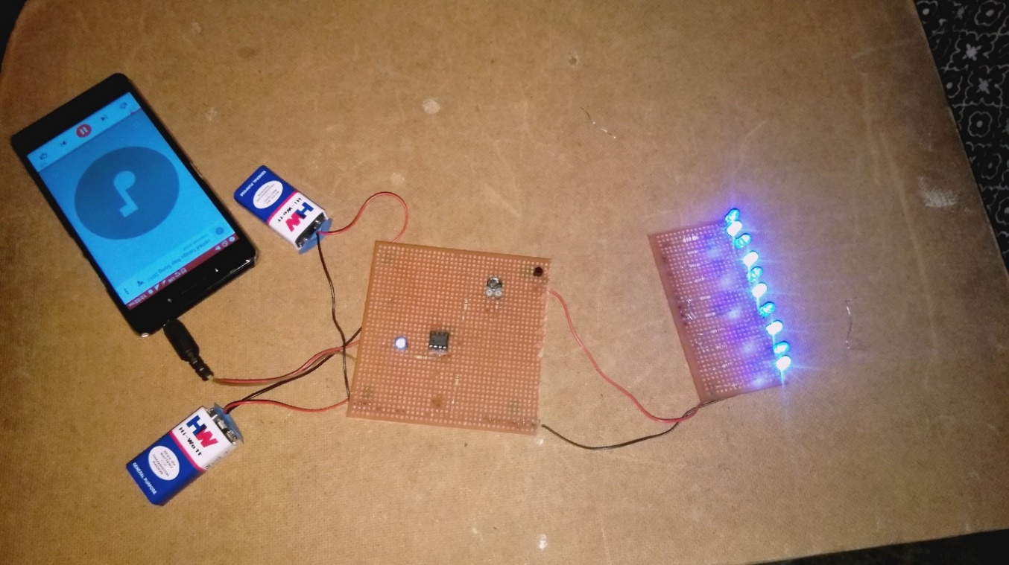

**Fig. 4.1**

The Receiver circuit along with the Photo Diode and the speaker connected to it is shown in the below figure,

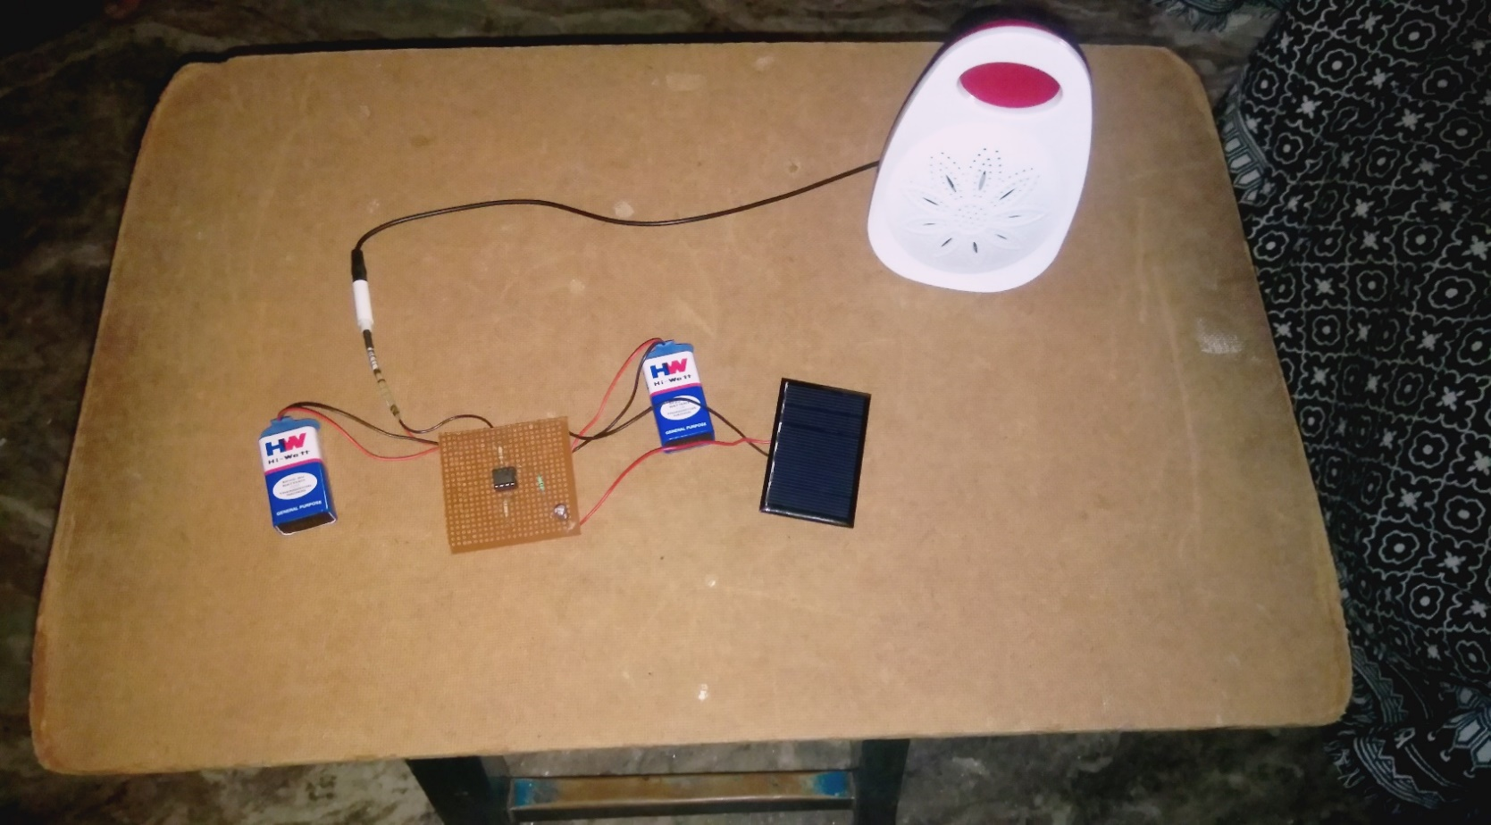

**Fig. 4.2**

These two figures represent the PCB layouts of the transmission and the receiver circuits implemented practically.

1. **Software functions**

The functions used for the design of software blocks are as follows,

1. **imread**

imread - Read image from graphics file.

A = imread(FILENAME, FMT) reads a grayscale or color image from the file specified by the string FILENAME. FILENAME must be in the current directory, in a directory on the MATLAB path, or include a full or relative path to a file. The text string FMT specifies the format of the file by its standard file extension. For example, specify 'gif' for Graphics Interchange

Format files. To see a list of supported formats, with their file extensions, use the IMFORMATS function. If imread cannot find a file named FILENAME, it looks for a file named FILENAME.FMT. The return value A is an array containing the image data. If the file contains a grayscale image, A is an M-by-N array. If the file contains a true color image, A is an M-by-N-by-3 array. For TIFF files containing color images that use the CMYK color space, A is an M-by-N-by-4 array. See TIFF in the Format-Specific Information section for more information.

1. **imshow**

imshow - Display image in Handle Graphics figure.

imshow(I) displays the grayscale image I.

imshow(I,[LOW HIGH]) displays the grayscale image I, specifying the display range for I in [LOW HIGH]. The value LOW (and any value less than LOW) displays as black, the value HIGH (and any value greater than HIGH) displays as white. Values in between are displayed as intermediate shades of gray, using the default number of gray levels.

imshow(I,[]) displays the grayscale image I scaling the display based on the range of pixel values in I. imshow uses [min(I(:)) max(I(:))] as the display range, that is, the minimum value in I is displayed as black, and the maximum value is displayed as white.

1. **rgb2gray**

rgb2gray - converts RGB values to grayscale values by forming a weighted sum of the R, G, and B components and returns a grayscale colormap equivalent to MAP.

1. **cat**

cat - Concatenate arrays.

B = cat(DIM, A1,A2,A3,A4,...) concatenates the input arrays A1, A2, etc. along the dimension DIM.

1. **VideoReader**

VideoReader - Create a multimedia reader object.

OBJ = VideoReader(FILENAME) constructs a multimedia reader object, OBJ, that can read in video data from a multimedia file. FILENAME is a string specifying the name of a multimedia file. There are no restrictions on file extensions. By default, MATLAB looks for the file FILENAME on the MATLAB path.

1. **imwrite**

imwrite - Write image to graphics file

The class of the image written to the file depends on the format specified. For most formats, if the input array is of class uint8, imwrite outputs the data as 8-bit values. If the input array is of class uint16 and the format supports 16-bit data (JPEG, PNG, and TIFF), imwrite outputs the data as 16-bit values. If the format does not support 16-bit values, imwrite issues an error. Several formats, such as JPEG and PNG, support a parameter that lets you specify the bit depth of the output data.

If the input array is of class double, and the image is a grayscale or RGB color image, imwrite assumes the dynamic range is [0,1] and automatically scales the data by 255 before writing it to the file as 8-bit values.

If the input array is of class double, and the image is an indexed image, imwrite converts the indices to zero-based indices by subtracting 1 from each element, and then writes the data as uint8.

If the input array is of class logical, imwrite assumes the data is a binary image and writes it to the file with a bit depth of 1 if the format allows it. BMP, PNG, or TIFF formats accept binary images as input arrays.

1. **reshape**

reshape - Reshape array.

reshape(X,M,N) or reshape(X,[M,N]) returns the M-by-N matrix whose elements are taken column wise from X. An error results if X does not have M*N elements.

1. **imresize**

imresize - Resize image.

B = imresize(A, SCALE) returns an image that is SCALE times the size of A, which is a grayscale, RGB, or binary image. If A has more than two dimensions, only the first two dimensions are resized.

B = imresize(A, [NUMROWS NUMCOLS]) resizes the image so that it has the specified number of rows and columns. Either NUMROWS or NUMCOLS may be NaN, in which case imresize computes the number of rows or columns automatically in order to preserve the image aspect ratio.

1. **implay**

implay - Play movies, videos, or image sequences.

implay opens a movie player for showing MATLAB movies, videos, or image sequences (also called image stacks). Use the implay File menu to select the movie or image sequence that you want to play. You can use implay controls to play the movie, jump to a specific frame in the sequence, change the frame rate of the display, or perform other exploration activities. You can open multiple implay movie players to view different movies simultaneously.

* + 1. **VideoWriter**

VideoWriter - Create a video writer object.

OBJ = VideoWriter(FILENAME) constructs a VideoWriter object to write video data to an AVI file that uses Motion JPEG compression. FILENAME is a string enclosed in single quotation marks that specifies the name of the file to create. If filename does not include the extension '.avi', the VideoWriter constructor appends the extension.

1. **Simulink Model**

The transmitter and receiver Simulink models and the blocks used in Matlab Simulink are as follows,

1. **Transmitter Simulink Model**

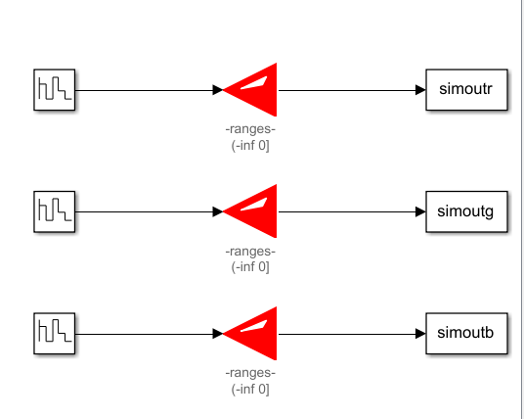

**Fig. 4.3** **Transmitter Simulink Model**

Simulink blocks used in the Transmitter Simulink Model:

1. **Repeating Sequence Stair**

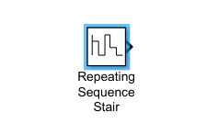

Description:

The Repeating Sequence Stair block outputs and repeats a stair sequence that you specify with the **Vector of output values** parameter. For example, you can specify the vector as[3 1 2 4 1]', which produces the following stair sequence:

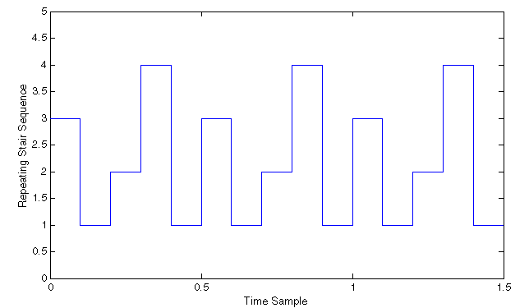

**Fig 4.4**

Sample time:

Specify the time interval between samples. To inherit the sample time, set this parameter to -1. See Specify Sample Time for more information.

Output minimum:

Specify the minimum value that the block should output. The default value is [] (unspecified). Simulink software uses this value to perform:

Parameter range checking (see Specify Minimum and Maximum Values for Block Parameters).

Simulation range checking (see Signal Ranges).

Automatic scaling of fixed-point data types.

Optimization of the code that you generate from the model. This optimization can remove algorithmic code and affect the results of some simulation modes such as SIL or external mode. For more information, see Optimize using the specified minimum and maximum values.

Output maximum:

Specify the maximum value that the block should output. The default value is [] (unspecified). Simulink software uses this value to perform:

Parameter range checking (see Specify Minimum and Maximum Values for Block Parameters).

Simulation range checking (see Signal Ranges).

Automatic scaling of fixed-point data types.

Optimization of the code that you generate from the model. This optimization can remove algorithmic code and affect the results of some simulation modes such as SIL or external mode. For more information, see Optimize using the specified minimum and maximum values.

Output data type:

Specify the output data type. You can set it to:

A rule that inherits a data type, for example, inherit: Inherit via back propagation. The name of a built-in data type, for example, single

The name of a data type object, for example, a Simulink.NumericType object. An expression that evaluates to a data type, for example, fixdt(1,16,0)

Characteristics:

**Table 4.1 Characteristics of Repeating Sequence Stair block:**

|  |  |
| --- | --- |
| Data Types | Double | Single | Boolean | Base Integer | Fixed-Point |
| Sample Time | Specified in the Sample time parameter |
| Multidimensional Signals | No |
| Variable-Size Signals | No |
| Zero-Crossing Detection | No |
| Code Generation | Yes |

1. **Simulink LED**

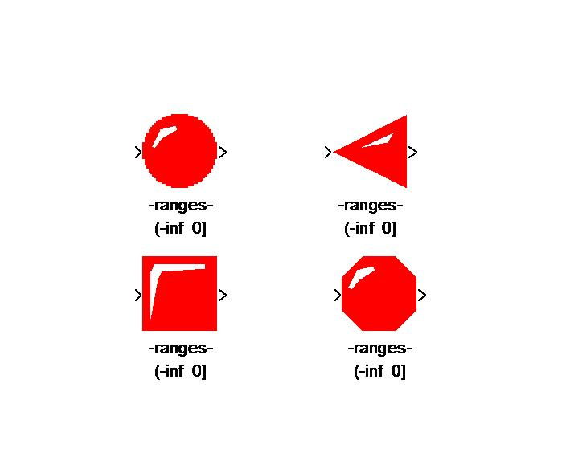

**Fig. 4.5** **Simulink LED**

Used to display status of signal.

'Outport' Checkbox is for displaying the current value,

the user can connect the outport with a display block,

the value from the outport of LED is equal to the inport.

The range syntax: (-inf 1]

(0.5 0.7)

[0 1]

(2 inf)

1. **To Workspace**

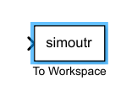

The To Workspace block inputs a signal and writes the signal data to a workspace. During the simulation, the block writes data to an internal buffer. When the simulation is completed or paused, that data is written to the workspace. Data is not available until the simulation is stopped or paused.

For menu-based simulation, data is written in the MATLAB® base workspace.

A sim command in a MATLAB function sends data logged with the to workspace block to the workspace of the calling function, not to the MATLAB (base)b workspace. To send the logged data to the base workspace, use an assign in command in the function

1. **Receiver Simulink Model**

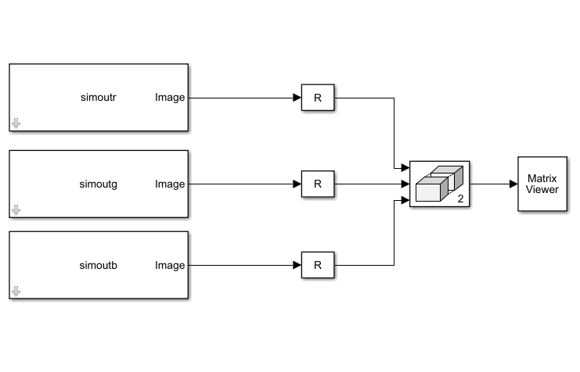

**Fig 4.6** **Receiver Simulink Model**

Simulink blocks used in the Receiver Simulink Model:

1. **From Workspace**

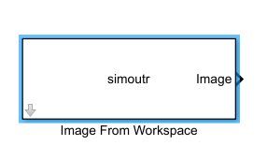

The From Workspace block reads signal data from a workspace and outputs the data as a signal.

The From Workspace icon displays the expression specified in the **Data** parameter. For details about how Simulink® software evaluates this expression, see Symbol Resolution.

You can specify how the data is loaded, including sample time, how to handle data for missing data points, and whether to use zero-crossing detection. For more information, see Load Data Using the From Workspace Block.

Specifying the Workspace Data

In the Block Parameters dialog box of the From Workspace block, in the **Data** parameter, specify the workspace data to load. Specify a MATLAB® expression (for example, the name of a variable in the MATLAB workspace) that evaluates to one of the following:

A MATLAB timeseries object

A structure of MATLAB timeseries objects

A structure, with or without time

A two-dimensional matrix

1. **Reshape**

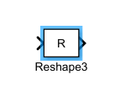

The Reshape block changes the dimensionality of the input signal to a dimensionality that you specify, using the block's **Output dimensionality** parameter. For example, you can use the block to change an N-element vector to a 1-by-N or N-by-1 matrix signal, and vice versa.

The **Output dimensionality** parameter lets you select any of the following output options.

**Table 4.2 Characteristics of Reshape block**

| **Output Dimensionality** | **Description** |
| --- | --- |
| 1-D array | Converts a multidimensional array to a vector (1-D array) array signal. The output vector consists of the first column of the input matrix followed by the second column, etc. (This option leaves a vector input unchanged.) |
| Column vector | Converts a vector, matrix, or multidimensional input signal to a column matrix, i.e., an M-by-1 matrix, where M is the number of elements in the input signal. For matrices, the conversion is done in column-major order. For multidimensional arrays, the conversion is done along the first dimension. |
| Row vector | Converts a vector, matrix, or multidimensional input signal to a row matrix, i.e., a 1-by-N matrix where N is the number of elements in the input signal. For matrices, the conversion is done in column-major order. For multidimensional arrays, the conversion is done along the first dimension. |
| Customize | Converts the input signal to an output signal whose dimensions you specify, using the **Output dimensions** parameter. The value of the **Output dimensions** parameter can be a one- or multi-element vector. A value of [N] outputs a vector of size N. A value of [M N] outputs an M-by-N matrix. The number of elements of the input signal must match the number of elements specified by the **Output dimensions** parameter. For multidimensional arrays, the conversion is done along the first dimension. |
| Derive from reference input port | Creates a second input port, Ref, on the block. Derives the dimensions of the output signal from the dimensions of the signal input to the Ref input port. Selecting this option disables the **Output dimensions** parameter. When you select this parameter, the input signals for both inport ports, U and Ref, must have the same sampling mode (sample-based or frame-based). |

1. **Matrix Concatenate**

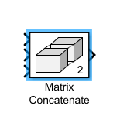

The Concatenate block concatenates the signals at its inputs to create an output signal whose elements reside in contiguous locations in memory. You use a Concatenate block to define an array of buses. For details about defining an array of buses, see Combine Buses into an Array of Buses. The Concatenate block operates in either vector or multidimensional array concatenation mode, depending on the setting of its Mode parameter. In either case, the block concatenates the inputs from the top to bottom, or left to right, input ports.

Vector Mode:

In vector mode, all input signals must be either vectors or row vectors [1xM matrices] or column vectors [Mx1 matrices] or a combination of vectors and either row or column vectors. The output is a vector if all inputs are vectors.

The output is a row or column vector if any of the inputs are row or column vectors, respectively.

Multidimensional Array Mode:

Multidimensional array mode accepts vectors and arrays of any size. It assumes that the trailing dimensions are all ones for input signals with lower dimensionality. For example, if the output is 4-D and the input is [2x3] (2-D) this block treats the input as [2x3x1x1]. The output is always an array. The block's Concatenate dimension parameter allows you to specify the output dimension along which the block concatenates its input arrays.

1. **Matrix Viewer**

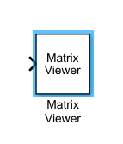

This block displays matrices as color images

The Matrix Viewer block displays an M-by-N matrix input by mapping the matrix element values to a specified range of colors. The display is updated as each new input is received. This block treats an unoriented length M vector input as an M-by-1 matrix. You can use the Matrix Viewer block in models running in Normal or Accelerator simulation modes. The software does not support this block in models running in Rapid Accelerator or External mode

1. **Hardware Output**

The hardware transmitter circuit and the complete circuit along with the receiver circuit tested at the time of simulating the output are placed as pictures below,

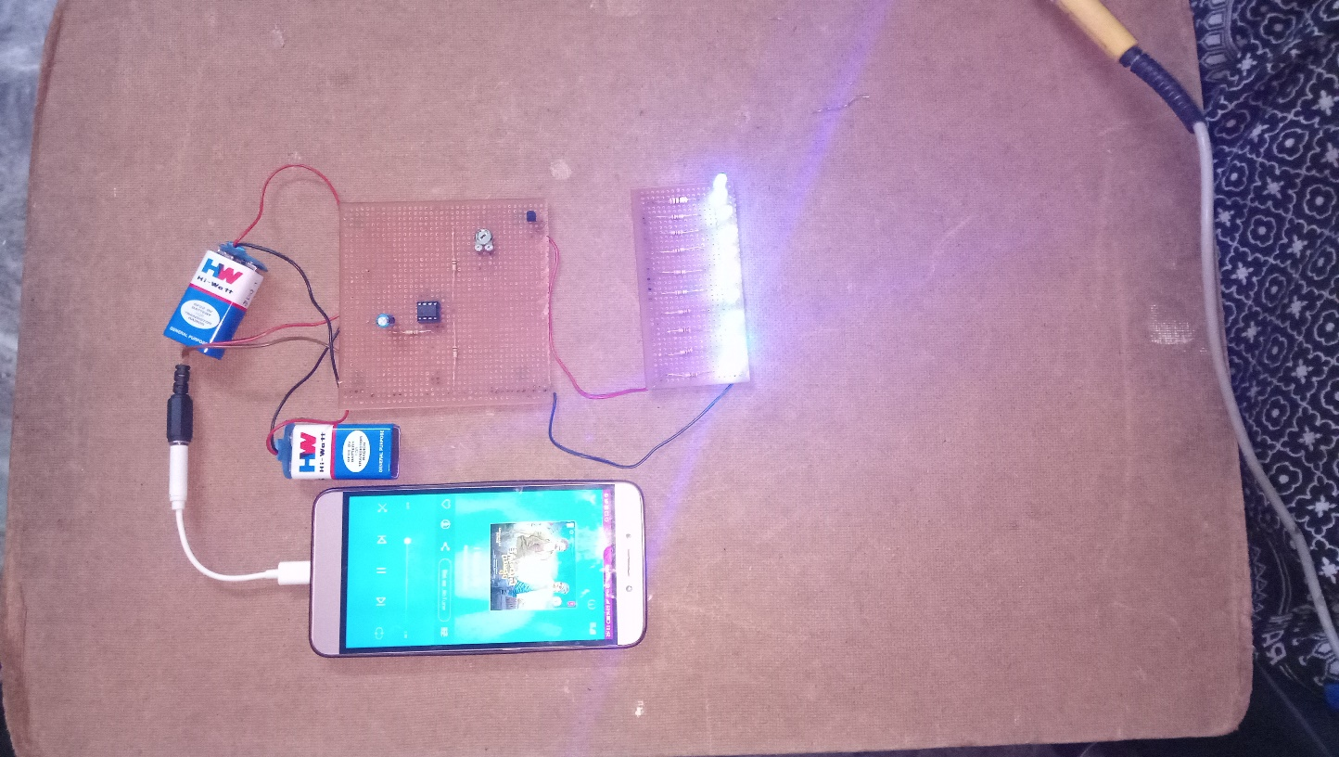

**Figure 4.7** **Hardware Transmitter Image**

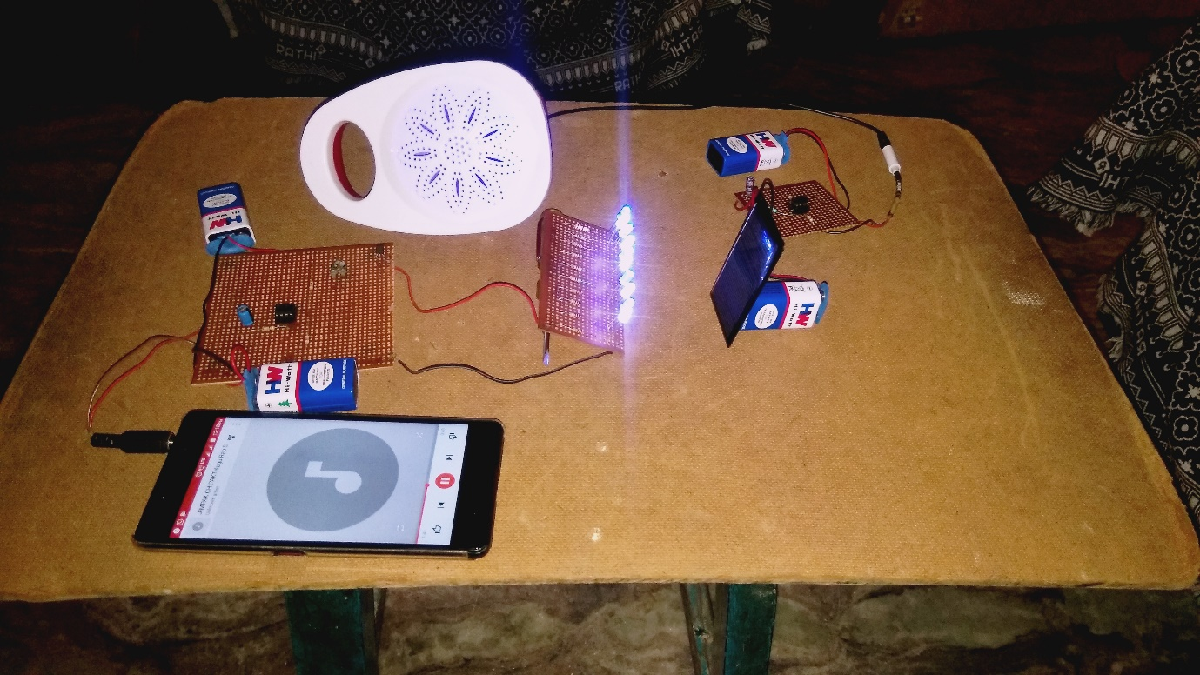

**Figure 4.8 Hardware Circuit Image**

1. **Software Output**

**RGB Image to Grayscale Conversion:**

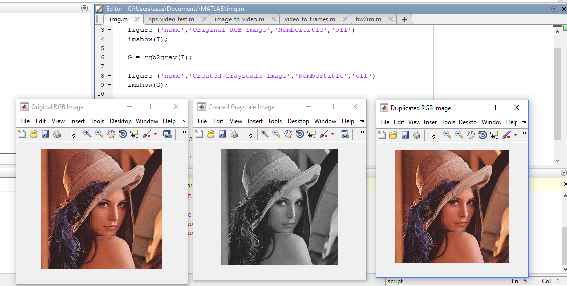

**Fig. 4.9** **Software Output-1**

This part of output corresponds to the ‘RGB Image to Grayscale’ and ‘Grayscale to RGB Image’ blocks used in the block diagram.

The first image displayed in the above picture is the original read RGB image.

The second picture displayed in the above picture is its converted grayscale image.

The last picture is the reconstructed RGB image from the converted grayscale image details.

**Video made into Frames:**

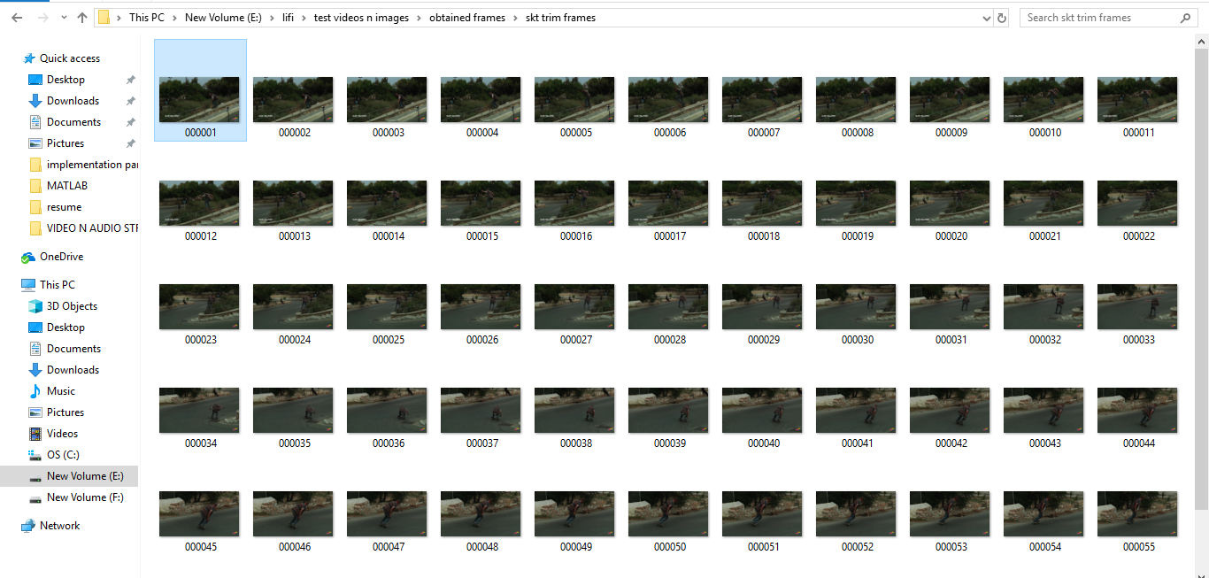

**Fig. 4.10 Software Output-2**

This part of output corresponds to the functioning of the block ‘Video to RGB frames’ represented in the block diagram.

This shows the functioning of the block as per the requirement of separating the input taken video into its contained number of frames.

The block is programmed according to the code written, separates the total number of its contained frames and finally saves them at our required location.

The above figure represents the total number of frames separated from the video and saved into the file manager of the system memory.

This block functions as per the code written and gives out the above shown output.

**Transmission and Reception of Images through LEDs:**

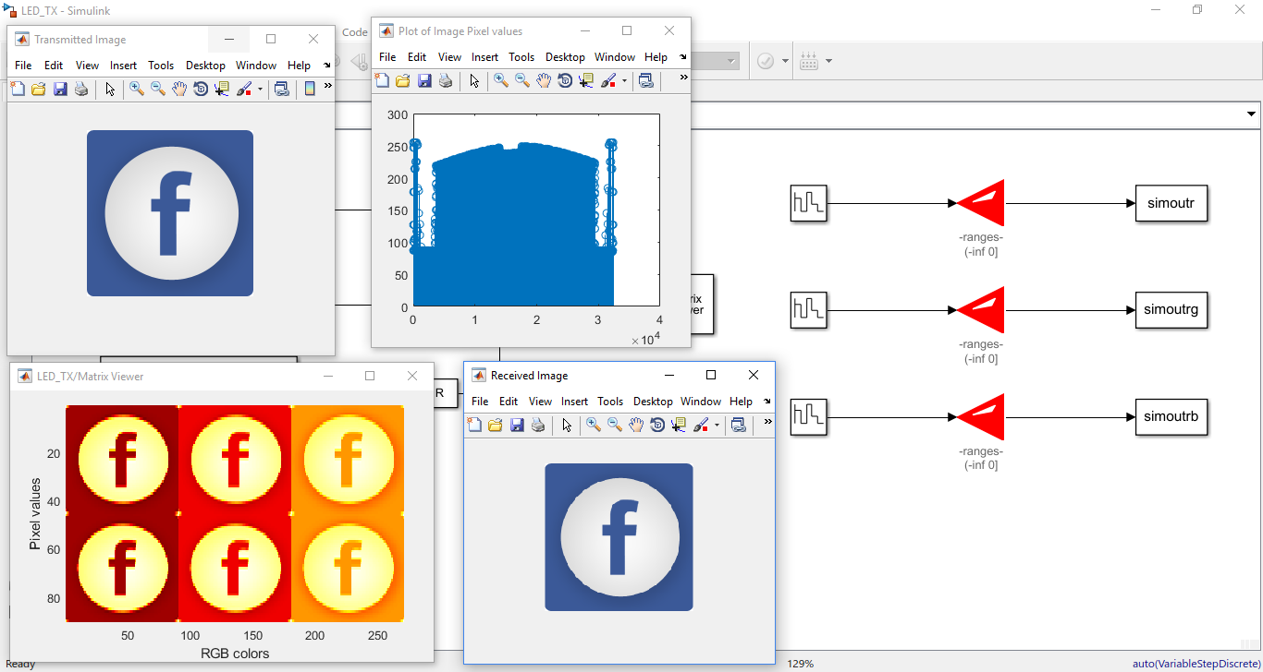

**Fig. 4.11** **Software Output-3**

This part of output corresponds to the ‘LED transmitter’ and ‘Photo Diode receiver’ blocks of the block diagram.

The first image represents the image which is to be transmitted through the LED.

The second image corresponds to the stem plot of the 1-D array created reshaping the MxN shaped array of the input image to 1x(Ni) shaped array.

The third image represents the separately concatenated grayscale red, green and blue image matrices received from the LED transmitter during the transmission of the original RGB image.

The fourth image corresponds to the output RGB image formed by recombining the received red, green and blue components.

These two blocks function according to the code written and as per the simulation done in the Simulink and give out an output as shown above.

**Video Joined from Frames:**

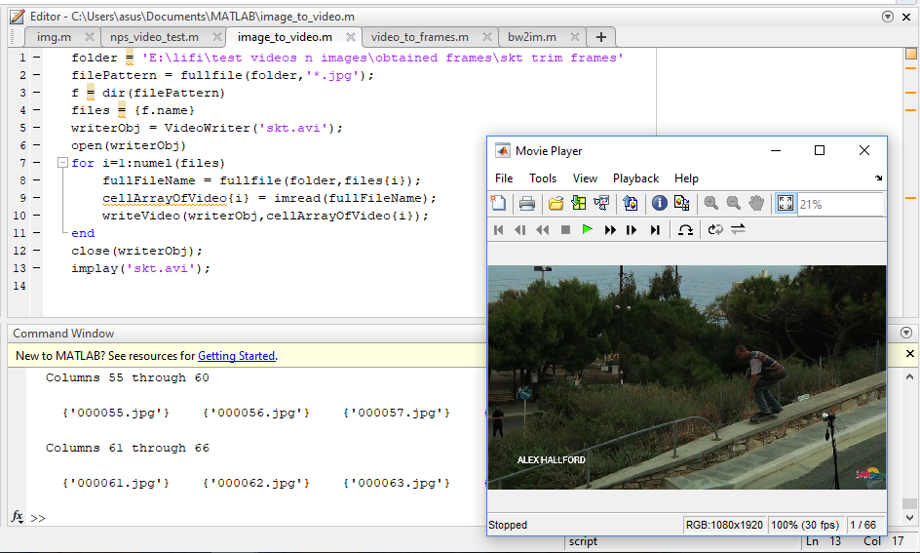

**Fig. 4.12** **Software Output-4**

This part of output corresponds to the ‘Frames to Video’ block of the block diagram.

This block accesses the location mentioned in the code and programs per the code written and functions to perform the video write operation.

It performs the function of joining images back into a video and with our required frame rate.

The video displayed in the above figure is the output video joined from the images saved in the memory location of the system.

This block functions as per the code written and gives out and output as shown above.

1. **Results**
2. **Hardware Results:**

The hardware transmitter circuit is connected and Pcb layout is done.

The LED transmitter circuit is connected and Pcb Layout is done.

The Photo Diode receiver circuit is connected and Pcb Layout is done.

The output of the transmitter and the glowing of the LEDs according to the given input is done and observed.

The output of the receiver and the audio input given is transmitted through the LED and played in the speaker without any noise.

The following are the pictures of the results of the transmitter and receiver blocks observed during the testing of the outputs,

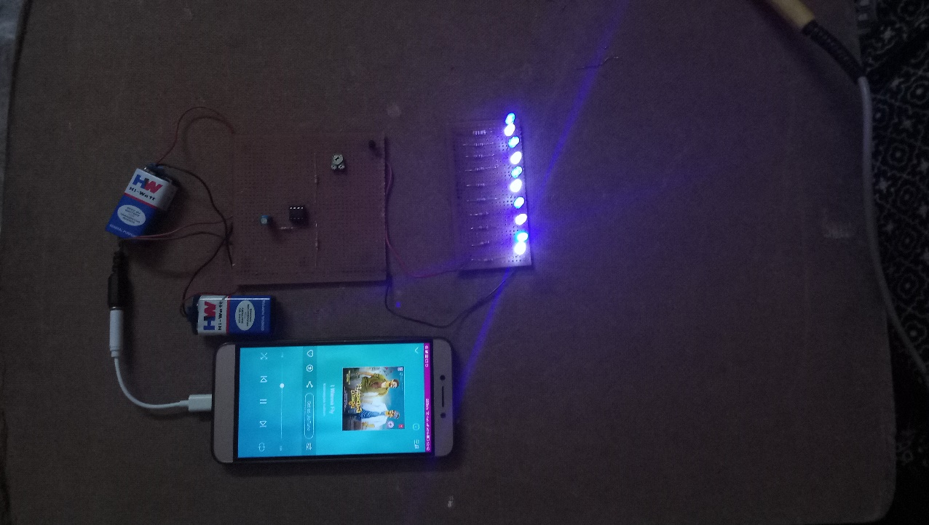

**Fig. 4.13** **Transmitter Result**

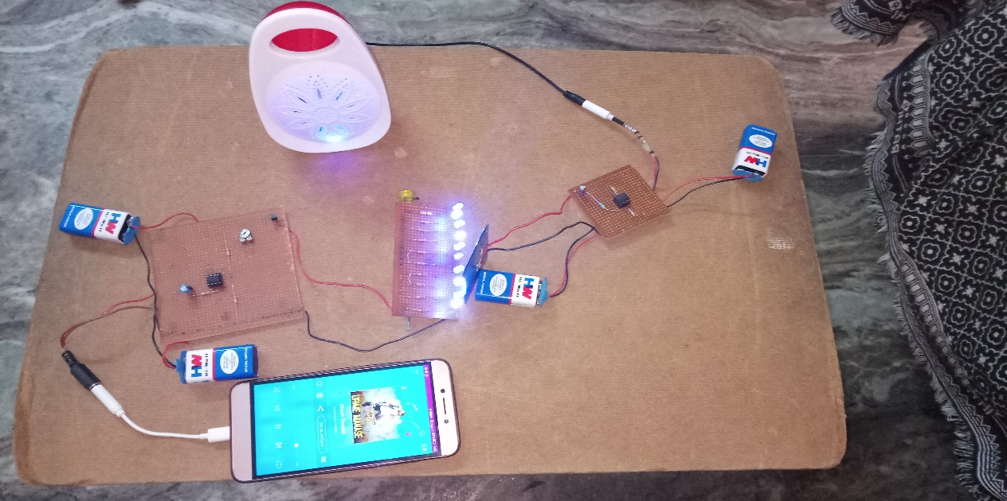

**Fig. 4.14** **Hardware Circuit Result.**

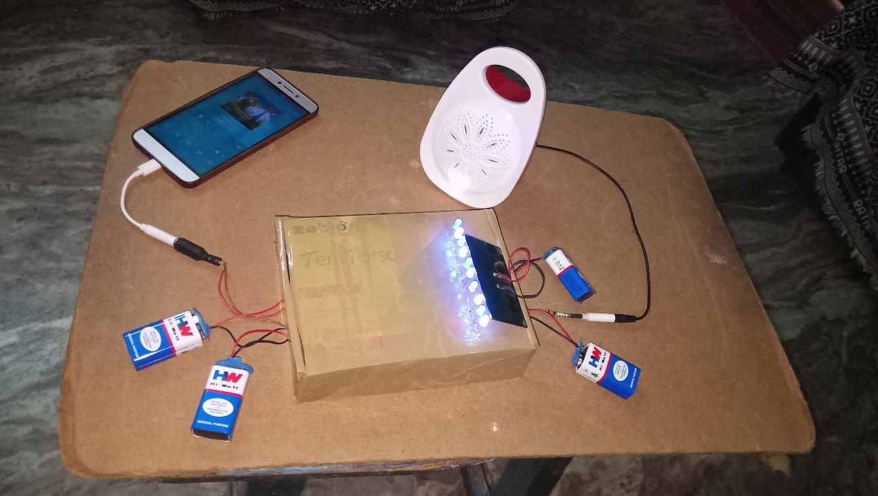

**Fig. 4.15** **Final Hardware setup and Result**

1. **Software Results:**

The following are the pictures of the video that is transmitted and received through the LED circuit in the Simulink model,

The below picture shows the image and the video which are to be transmitted as inputs.

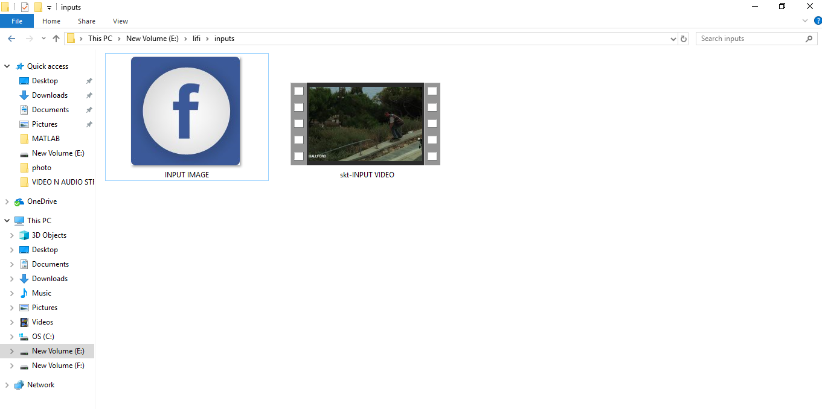

**Fig. 4.16** **Software Transmitted Inputs**

The below picture shows the location in system memory where the image and the video after transmission are saved.

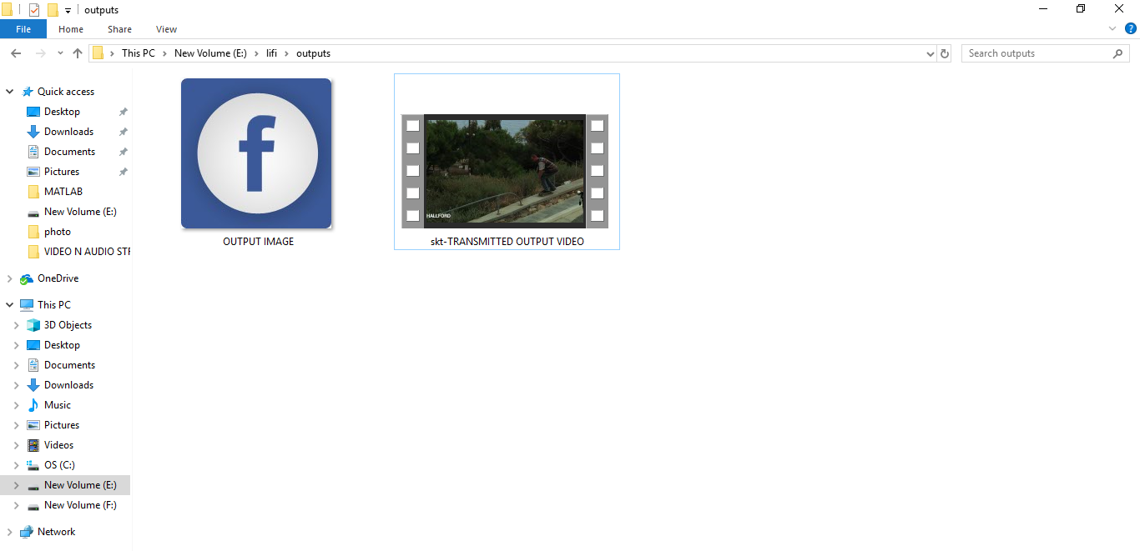

**Fig. 4.17** **Software Received Outputs**

The below picture shows the output video transmitted through the LED block in our constructed Simulink model.

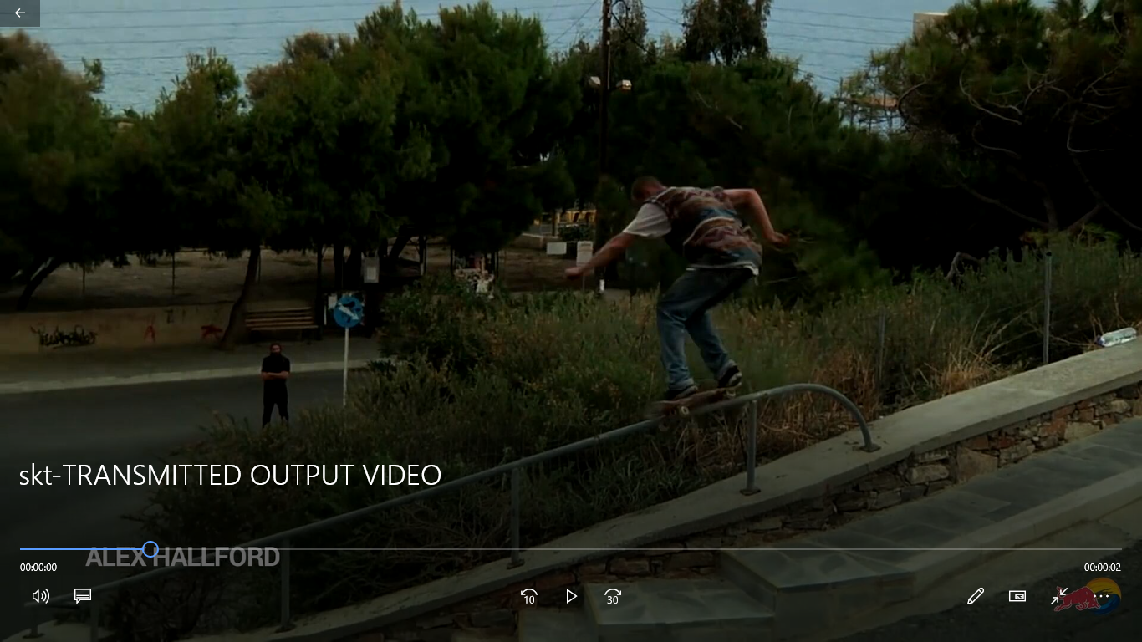

**Fig. 4.18** **Software Transmitted Video Output**

**CHAPTER-5**

**VALIDATION**

1. **Advantages**

Li-Fi, which uses visible light to transmit signals wirelessly, is an emerging technology poised to compete with Wi-Fi. Also, Li-Fi removes the limitations that have been put on the user by the Radio wave transmission such as Wi-Fi as explained above vide 4.1. Advantages of Li-Fi technology include:

1. *Efficiency:* Energy consumption can be minimized with the use of LED illumination which are already available in the home, offices and Mall etc. for lighting purpose. Hence the transmission of data requiring negligible additional power, which makes it very efficient in terms of costs as well as energy.
2. *High speed:* Combination of low interference, high bandwidths and high-intensity output, help Li-Fi provide high data rates i.e. 1 Gbps or even beyond.
3. *Availability:* Availability is not an issue as light sources are present everywhere.

Wherever there is a light source, there can be Internet. Light bulbs are present everywhere – in homes, offices, shops, malls and even planes, which can be used as a medium for the data transmission.

1. *Cheaper*: Li-Fi not only requires fewer components for its working, but also uses only a negligible additional power for the data transmission.
2. *Security:* One main advantage of Li-Fi is security. Since light cannot pass through opaque structures, Li-Fi internet is available only to the users within a confined area and cannot be intercepted and misused, outside the area under operation.
3. Li-Fi technology has a great scope in future. The extensive growth in the use of LEDs for illumination indeed provides the opportunity to integrate the technology into a plethora of environments and applications.

Here is a table for a clear understanding of the differences between the three technologies:

**Table 5.1 Comparison between Bluetooth, Li-Fi and Wi-Fi technologies**

|  |  |  |  |
| --- | --- | --- | --- |
|  | **iBeacon** | **Li-Fi** | **Wi-Fi** |
| **Range** | The typical range of Bluetooth low-energy radio module is up to 70 m (230 ft) | In case of Li-Fi, you can receive the data as long as you are in the range of the light being emitted from an LED light source. So, the range depends on the strength of the light which is being emitted | The range of Wi-Fi networks depends on the transmission power, antenna type, and the location they're used in. In an indoor point-to-multipoint arrangement, a router using 802.11b or 802.11g and a stock antenna might have a range of 32 m (105 ft) |
| Compatibility | All Bluetooth 4.0-enabled devices are capable of picking up BLE signals | Li-Fi is compatible with IrDa devices | Wi-Fi is compatible with WLAN  802.11 a/b/g/n/ac/ad devices |
| **Cost** | While a beacon would cost anywhere between $10-$70, the cost of beacon system depends on a number of other factors such as app and integration cost, licensing and data service cost | Since Li-Fi can work with the existing LED devices, the installation cost is much less. However, it requires an existing LED lighting system in place | You will need a router for Wi-Fi. While the cost of a router generally varies depending on the manufacturer, getting a high-traffic router can be quite expensive |
| **Energy**  **Efficiency** | Majority of beacons are battery powered and last for up to one year before they need to be replaced | LED bulbs use 85% less energy than incandescent bulbs and last up to 20 times longer | You need to configure and connect routers to a power source for the Wi-  Fi to work |
| **Privacy** | Beacons require a consumer’s consent to interact with their smartphone | A consumer can choose to receive data by keeping the smartphone in the range of LED light or can simply put away the phone in his/her pocket to avoid it | Wi-Fi technology does not explicitly ask consumers for their permission, as it does not require any user intervention. The only way out of it is to completely disable Wi-Fi on their mobile device |

COMPARISON OF LI-FI AND WI-MAX TECHNOLOGIES:

**Table 5.2 Differences in Li- Fi and Wi-Max technologies:**

|  |  |  |
| --- | --- | --- |
|  | LI-FI | WI-MAX |
| IEEE STANDARD | 802.15.7 | 802.16a |
| SPEED | 100 times faster than Wi-Max | 100 times faster than WI-FI |
| RANGE | 10 meters | 30-100 meters |
| FREQUENCY BAND | 100 times of THz | 2-11 GHz |
| TECHNOLOGY USED | Light Fidelity | Microwave |
| NETWORK TOPOLOGY | Point-to-Point | Point-to-Multi Point |
| SPECTRUM RANGE | 10000 times than WI-FI | 10-66 GHz |

**Table 5.3 Comparison of speed of various wireless technologies**

|  |  |
| --- | --- |
| *Technology* | *Speed* |
| *Li-Fi* | ~1 Gbps |
| *Wi-Fi – IEEE 802.11n* | ~150 Mbps |
| *IrDA* | ~4 Mbps |
| *Bluetooth* | ~3 Mbps |
| *NFC* | ~424 Kbps |

1. **Disadvantages**

Some of the major limitations of Li-Fi are:

1. Internet cannot be accessed without a light source. This could limit the locations and situations in which Li-Fi could be used.
2. It requires a near or perfect line-of-sight to transmit data
3. Opaque obstacles on pathways can affect data transmission
4. Natural light, sunlight, and normal electric light can affect the data transmission speed
5. Light waves don’t penetrate through walls and so Li-Fi has a much shorter range than Wi-Fi High initial installation cost, if used to set up a full-fledged data network.
6. Yet to be developed for mass scale adoption.
7. If the apparatus is set up outdoors, it would need to deal with changing weather conditions.
8. If the apparatus is set up indoors, one would not be able to shift the receiver.
9. The problem of how the receiver will transmit back to the transmitter persists.
10. Light waves can easily be blocked and cannot penetrate thick walls like the radio waves can.
11. We become dependent on the light source for internet access. If the light source malfunctions, we lose access to the internet.
12. **Applications**

Due to its advantages, Li-Fi has a lot of Life applications. Here we will talk about some important applications of it.

1. Underwater Communications

Using RF signals is impractical due to strong signal absorption in water. Li-Fi provides a solution for shortrange communications. Submarines could use their headlamps to communicate with each other, process data autonomously and send their findings periodically back to the surface in Underwater Remotely Operated Vehicles (ROV). Another important issue is that Li-Fi can even work underwater where Wi-Fi fails completely, thereby it’s open for military operations.

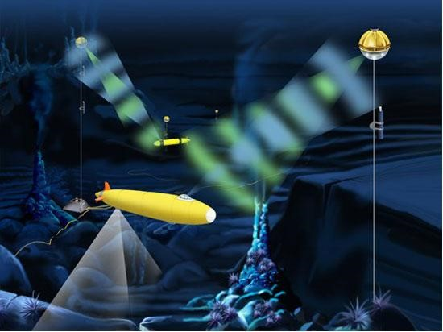

**Fig. 5.1 Optical Underwater Communications system.**

Figure 5.1 shows water vehicles which use light to communicate with each other and transfer data between them.

1. Traffic Management

Li-Fi can help in managing the traffic in a better manner and the accident numbers can be decreased. Traffic lights can communicate to the car and with each other to manage the traffic in the street.

Traffic light can play the role of the sender of the data to provide information to the car on the status of the road or about the situation of other cars as shown in Figure 9. Also, cars can communicate with each other and prevent accidents by exchanging information. For example, LED car lights can alert drivers when other vehicles are too close.

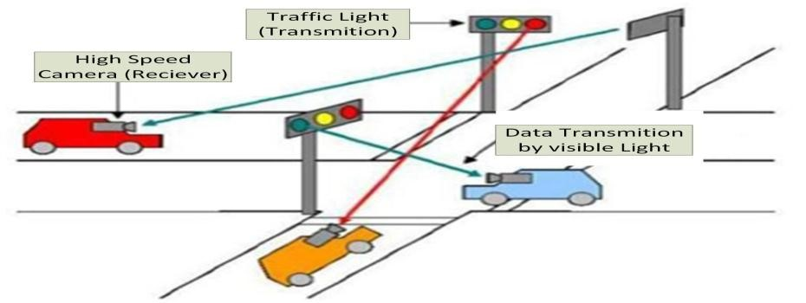

**Fig. 5.2 Vehicle Visible Light Communications.**

1. Airways

We must switch off mobiles in aircrafts to prevent overlapping of mobile phone signals with navigation and control signals used by aircraft. Li-Fi can be safely used on planes because it doesn't interfere with RF. Since it Data is present where light is present, we can use the lights above the seats in the plane as hotspot.

1. Medical Applications

One of the most important features of Li-Fi is that it could be used in hospitals and medical settings that require the lack of RF signals which affect the medical equipment. For example, OTs (Operation theatres) do not allow using Wi-Fi due to radiation concerns because usage of Wi-Fi blocks the signals for monitoring equipment’s. So, it may be dangerous to the patient's health.

1. Blind Indoor Navigation System

Indoor navigation is convenient for everyone, and it is especially indispensable for the visually impaired. We proposed such a navigation system for the visually impaired as shown in Figure 10. LED lights emit visible light with location data and an embedded system or smartphone with a visible light receiver which receives the data. The embedded system or smartphone calculates the optimal path to a designation and speaks to the visually impaired through a headphone.

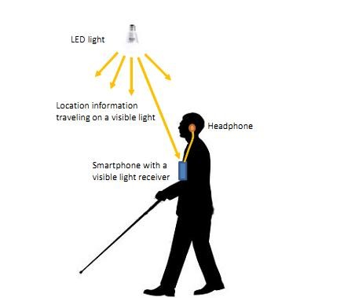

**Fig. 5.3 Indoor Navigation system for Blind people.**

1. In Sensitive Areas or in Hazardous Environments

Li-Fi provides a safe communication in environments such as mines and petrochemical plants because it doesn’t cause electromagnetic interference which appears in RF communications. Li-Fi can also be used in petroleum or chemical plants where other frequencies could be hazardous.

For example, power plants like nuclear power plants require grid integrity and monitoring of the station temperature that need fast, inter-connected data systems. Wi-Fi and many other radiation types are bad for sensitive areas surrounding the power plants. Li-Fi could offer safe, abundant connectivity for all areas of these sensitive locations.

Moreover, this technology also enables us to control plants and their growth without direct presence.

1. Disaster Management

Li-Fi can be used as a powerful means of communication at times of disaster such as earthquake or hurricanes, for example places like subway stations and tunnels which are common dead zones for most emergency communications, don’t pose obstruction for Li-Fi, so it can be used there, as emergency communication.

**CHAPTER-6**

**CONCLUSION**

**Conclusions**

Although LIFI has some disadvantages but it shows epic advancement in the world of wireless technology. It hits almost all sectors and going to be boon for our society. LIFI technology has shown lots of improvements since it has discovered. So, these signals will provide many facilities in future.

Since light doesn’t penetrate through walls and any other opaque objects this can be concluded as the best medium current prevailing for transmission of data.

The PCB board circuit is used for audio simulation and the Simulink data is used for image and video simulations.

This project deals with the transmission of audio, video and image signals through LEDs with light as carrier signals medium. Since light is the fastest known travelling medium the data rates experienced through this medium are of much higher rates than the currently prevailing Wi-Fi and Bluetooth technologies.

We can access internet anywhere in streets, footpaths, house, etc. with the help of available light source such as tube-light, lamps, street-lights etc.

Since LED’s are fast switching easily available cheap low power consumption and hence can be used in large amount to transfer data in a mere blink of an eye.

In field of data electronics, it provides ample ways to transfer signals and its relative data to the greatest accuracy and in the most precise way.

Communicating and obtaining data from satellite will be easier than ever before.

It will be beneficial for defense services as their data is very confidential and LIFI cannot be hacked so data is protected. For marine commandos, who operates under water can send important commands to other areas (either under water or in land etc.) since LIFI signals works under water. With the hands provided by LIFI we will be future ready.

**Future Scope**

As Li-Fi becomes more commercialized, it will usher in an era of incredible business opportunities, such as allowing telecom service providers to reach out to a wider customer base. There will be broader accessibility with Li-Fi Cloud. Smartphones will soon be able to download traffic information from traffic lights or a program guide from a television. In the future, shops will transmit advertisements to our phone as we pass by and bus schedule changes will be transmitted to a screen at the stop. Smarter home appliances that talk machine-to-machine (M2M) are already being extensively researched, where LED lights on electronics function as Li-Fi access points.

The LED block used in Simulink in this project allows only single input for one transmission. Since, for that reason the conversion of the image is done into a row vector and later into a staircase signal. This results in a delayed transmission of the image through our LEDs, if the LEDs working is functioned as per the acceptance of multiple array inputs the conversion into a row vector need not to be done and the transmission can be done in a much faster rates.

*Li-Fi Roadmap:*

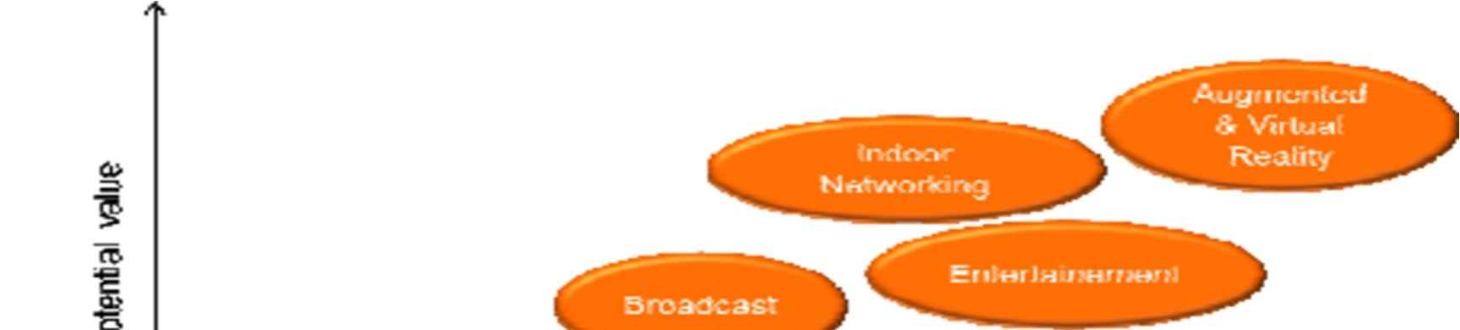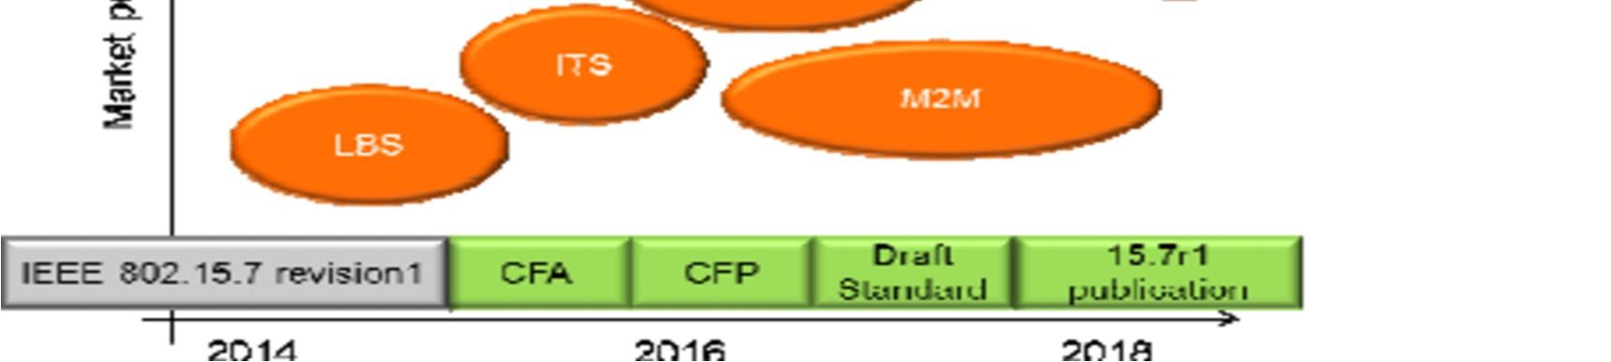

**Fig. 6.1 Li-Fi Roadmap**

Currently, LBS (location Based Service) or Broadcast solution are commercially available. The next step could be a Li-Fi WLAN for B2B market with high added value on specific business cases and could grow towards mass market. In the long term, the Li-Fi could become an alternative solution to radio for wireless high data rate room connectivity and new adapted service, such as augmented or virtual reality.

**CHAPTER-7**

**REFERENCES**

[1] Optics and Photonics Journal, 2013, 3, 153-157 doi:10.4236/opj.2013.32B037 Published Online June 2013 “Li-Fi (Light Fidelity)-The future technology In Wireless communication?” by Jyoti Rani. “Journal from International Journal of Applied Engineering Research” (IJAER); ISSN 0973-4562 Vol.7 No.11 (2012)

[2] Principles of LED Light Communications: Towards Networked Li-Fi by Svilen Dimitrov (Author),‎ Harald Haas (Author) Volume 18 – No.14, November 2015

[3] Li-Fi Technology for Indoor Access by Gado Moham (Author),‎ Abd El- Moghith Doaa (Author)

[4] Visible-light communication: Tripping the light fantastic: A fast and cheap optical version of Wi-Fi is coming‖, Economist, dated 28 Jan 2012**.**

[5] S. Dimitrov and H. Haas, ptimum Signal Shaping in OFDM-Based Optical Wireless Communication Systems, in Vehicular Technology Conference (VTC Fall), Sept 2012 IEEE.

[6] International Journal for Trends in Engineering & Technology volume 23 issue 1 - May 2017 - ISSN: 2349 – 930.

[7] Imperial Journal of Interdisciplinary Research (IJIR) Vol-2, Issue-6, 2016 ISSN: 2454-1362

[8] T. D. C. Little, P. Dib, K. Shah, N. Barra Ford and B. Gallagher, “Using LED Lighting for Ubiquitous Indoor Wireless Networking,” IEEE International Conference on Wireless and Mobile Computing, pp. 373-378, 2008. doi:10.1109/WiMob.2008.57

[9] Wirelessly Transmitting a Grayscale Image using Visible Light from International Journal of Computer Applications (0975 – 8887) Volume 58– No.14, November 2012

[10] Ian Lim, Li-Fi Internet at the Speed of Light, the gadgeteer, 29 August 2011 Volume 58– No.14.

[11] International Journal of Innovative Research in Electrical, Electronics, Instrumentation and Control EngineeringISO 3297:2007 Certified Vol. 4, Issue 11, November 2016

[12] International Journal of Innovative Research in Advanced Engineering (IJIRAE) ISSN: 2349-2163 Issue 6, Volume 2 (June 2015)

[13] Dinesh Khandal, Sakshi Jain “Li-Fi (Light Fidelity): The Future Technology in Wireless Communication” International Journal of Information & Computation Technology. ISSN 0974-2239 Volume 4, Number 16 (2014)

[14] Qian Huang, Xiaohang Li, Mark Shaurette “Integrating Li-Fi Wireless Communication and Energy Harvesting Wireless Sensor for Next Generation Building Management” International High-Performance Building Conference, Purdue University.

[15] Dharmrajsinh N. Parmar, Khushbu V. Mehta Jay H. Bhut, "Li-Fi Technology – A Visible Light Communication," *INTERNATIONAL JOURNAL OF ENGINEERING DEVELOPMENT AND RESEARCH*, Jan 2014.

[16] Richard Gilliard, "The li-fi® lamp high efficiency high brightness light emitting plasma with long life and excellent color quality," IEEE, Sunnyvale, USA, 2010.